**1. Why Cloud?**

==> Before the advent of cloud computing, hosting a website required organizations to invest heavily in physical servers and infrastructure. This approach presented several significant challenges:

* 1. **High Capital Expenditure**: Purchasing and setting up physical servers demanded substantial upfront investment, making it a costly endeavor for many businesses.
  2. **Traffic Management Difficulties**: Web traffic is inherently variable, with fluctuations throughout the day. Traditional hosting environments struggled to adapt to these changes efficiently, often leading to either over-provisioning (resulting in wasted resources) or under-provisioning (causing slow load times or downtime during traffic spikes).
  3. **Complex Maintenance and Monitoring**: Managing physical servers required dedicated IT personnel to handle regular maintenance, updates, and monitoring. This not only increased operational costs but also diverted focus from core business activities.

These challenges underscored the limitations of traditional web hosting methods, paving the way for more flexible and scalable solutions like cloud computing.

**2. What is Cloud Computing?**

==> Cloud computing provides the ability to store, process, and access data from anywhere in the world with a good internet connection. It breaks geographical barriers by allowing users to deploy resources in one location, such as the U.S., and access or manage them from regions like China or India. This accessibility makes cloud computing highly versatile and globally effective.

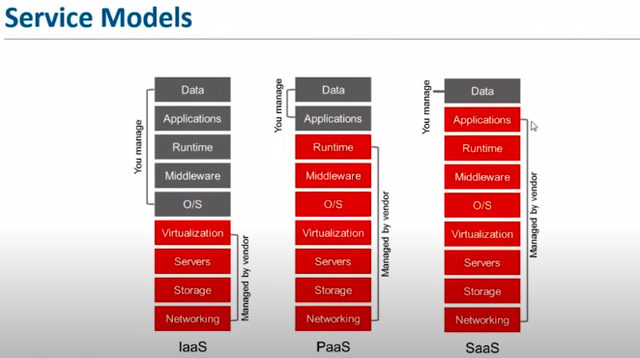

Next, diving into service models:

1. **Infrastructure as a Service (IaaS):** Offers essential computing resources like servers and storage on demand.
2. **Platform as a Service (PaaS):** Provides a platform for developers to build and deploy applications without managing the underlying infrastructure.
3. **Software as a Service (SaaS):** Supplies fully functional software applications via the internet, simplifying access and maintenance.

These models cater to different needs, providing flexibility and scalability to businesses and developers.

**3.** **Cloud Deployment Model -**

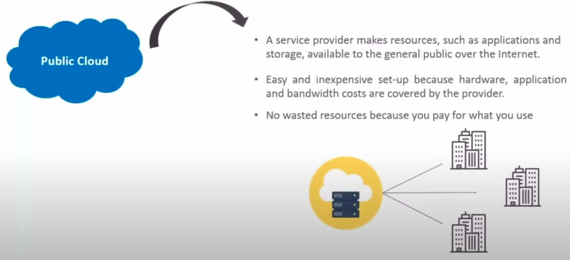

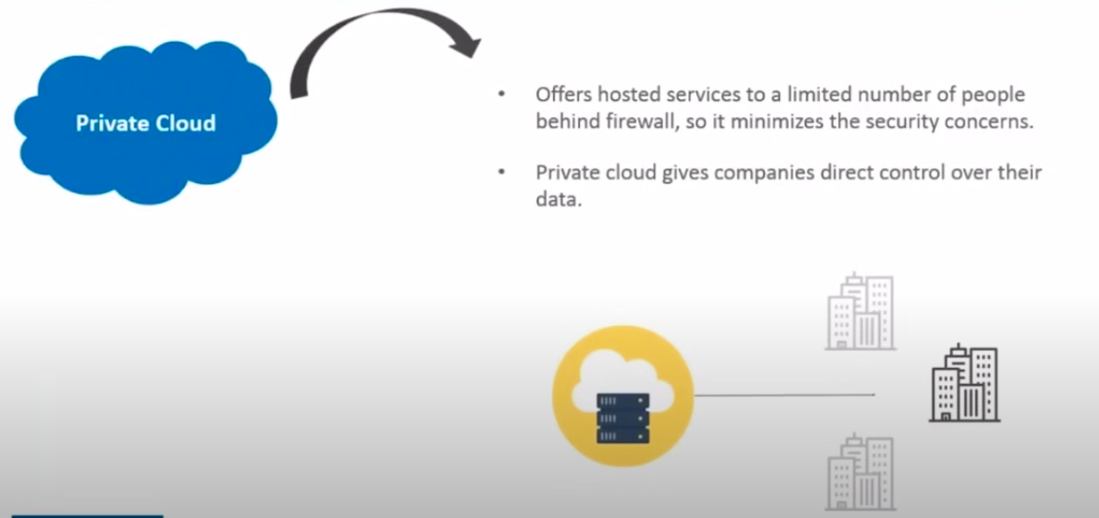

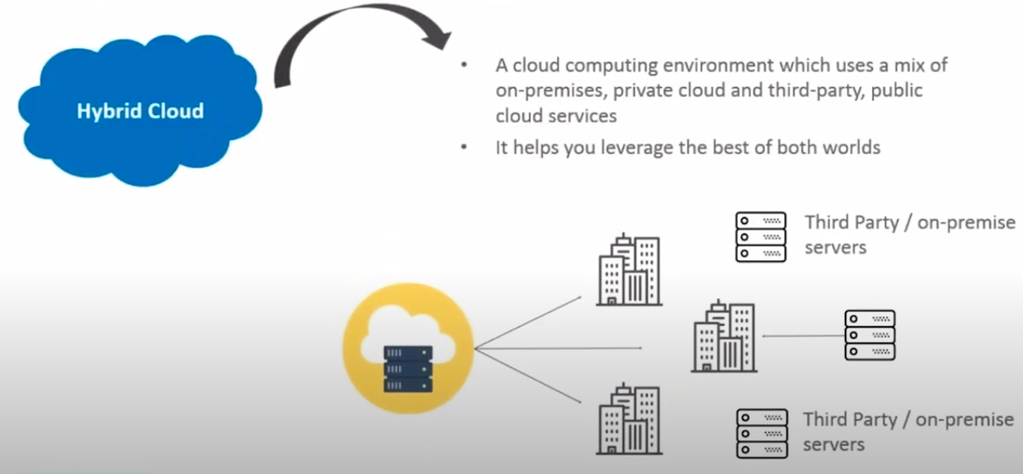

**4. Cloud Providers -**

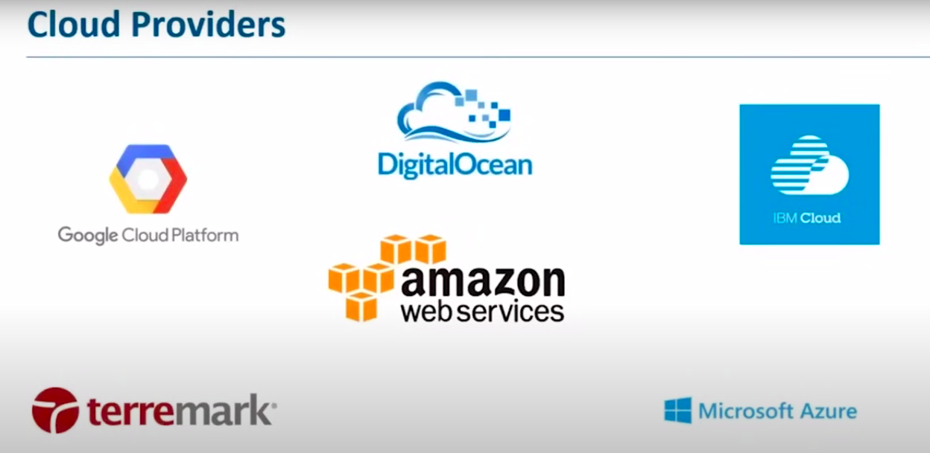

**5. Introduction to AWS -**

AWS is highly secure and offers a wide range of services, including compute, storage, databases, and more, which we will explore further in the upcoming slides. In the cloud services market, AWS stands out as the leader for several reasons, such as its flexibility, scalability, and competitive pricing. Another key factor is its massive compute capacity.

Why is compute capacity so important? If you consider the combined compute power of all other cloud service providers in the market, it would amount to a certain value, let's call it "X." Now, AWS’s compute capacity is six times that value—6X—making it significantly more powerful than any other provider in the industry. This immense capacity is a major reason why AWS is considered the best in the market.

In this section, we will also explore other features, services, and use cases of AWS. For instance, let’s look at how AWS can benefit a manufacturing organization.

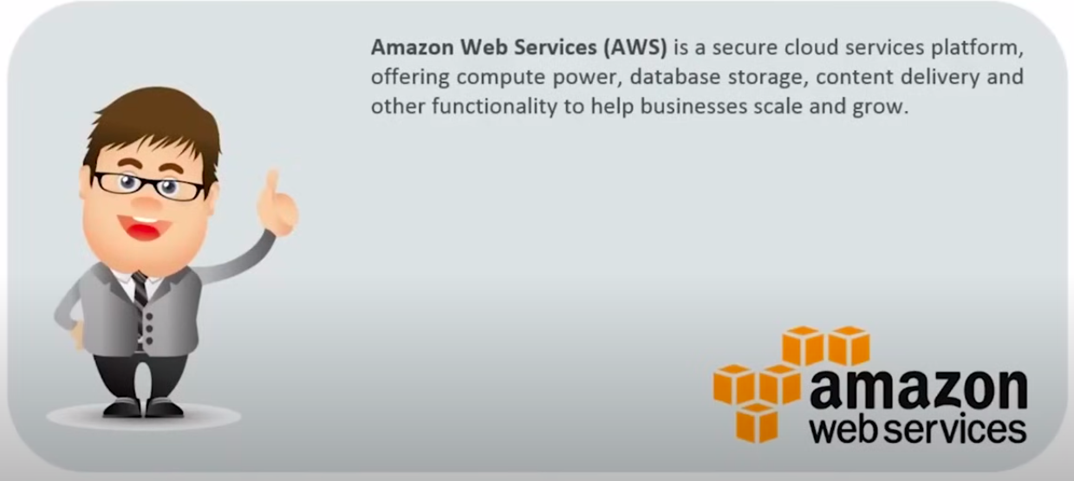

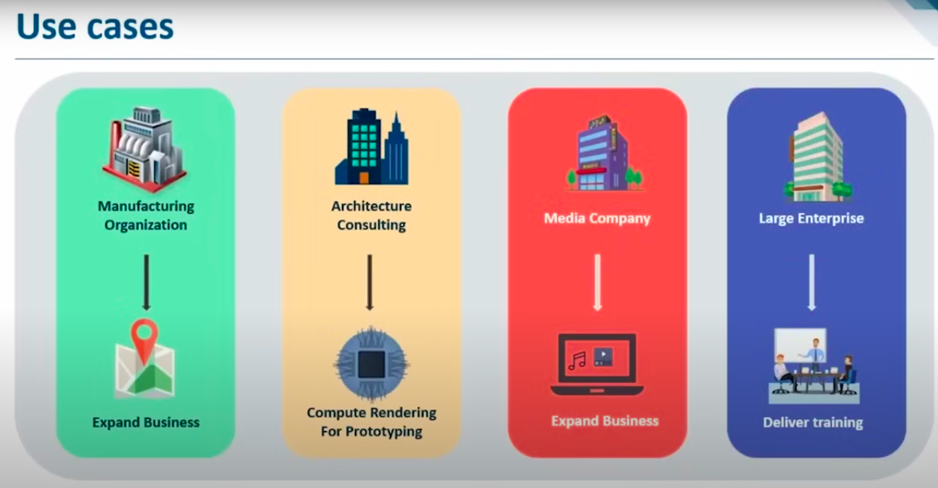

**6. Advantage of AWS -**

AWS offers excellent flexibility and cost-effectiveness, making it an ideal choice for many organizations. Let’s dive into these two aspects.

**Flexibility:** AWS is highly flexible, which is crucial for handling large-scale data management, deployment, and maintenance in big organizations. When choosing a cloud provider, flexibility ensures that these tasks are efficiently managed without compromising performance.

**Cost-effectiveness:** AWS is also known for being cost-effective. For beginners or learners, AWS offers a Free Tier, which provides access to sufficient resources free of charge for one year, allowing users to gain hands-on experience without any financial commitment. Additionally, AWS operates on a pay-as-you-go model. This means you only pay for the services you use and only for the time you use them. If you’re utilizing a service for an hour, you’re charged only for that hour. This model helps keep costs low while offering the flexibility to scale resources as needed.

**Scalability:** AWS offers incredible scalability, allowing you to scale resources up or down based on your requirements. This is particularly valuable because you can start with fewer resources and scale as your needs grow. AWS also provides automatic scheduling for some services, which means you can automatically shut down resources during downtime to avoid unnecessary costs.

**Security:** Security is a common concern when it comes to cloud services, but AWS addresses this effectively with robust security mechanisms. AWS provides a wide range of compliance programs to ensure your data is secure, and its real-time security measures help detect and manage suspicious activities, allowing you to focus on your business without worrying about security.

**Additional Benefits:** AWS also supports various integrated APIs in different programming languages, which strengthens its architecture and allows you to switch between programming languages seamlessly. This flexibility, along with features like automatic scheduling, makes AWS a powerful and efficient service provider in the cloud market.

Now that we've covered these key benefits, let's move on and explore other aspects of AWS, particularly in relation to databases.

**7. AWS Architecture-**

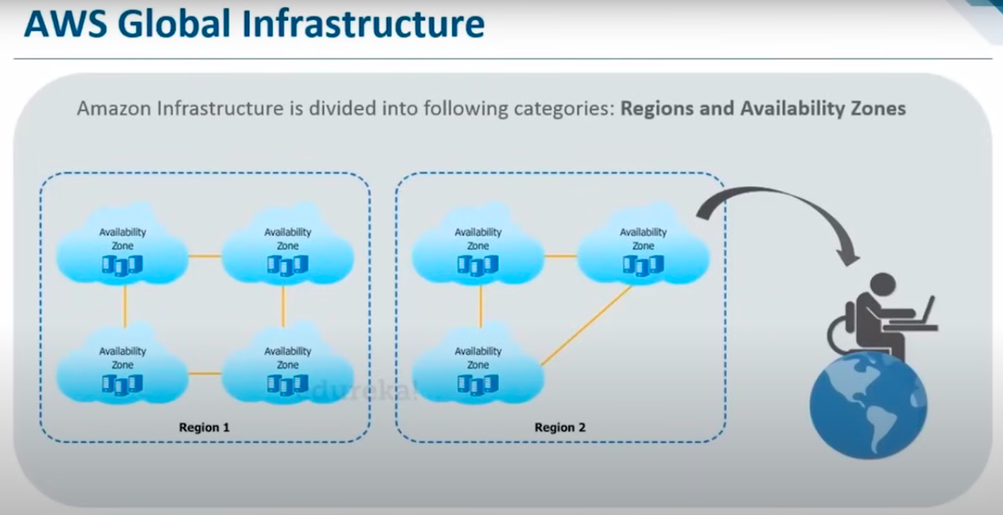

AWS's global architecture is one of the key reasons for its popularity and dominance in the cloud services market. The architecture is designed to be extensive and well-distributed, covering almost every area that needs to be addressed.

The architecture is divided into two primary components: Regions and Availability Zones.

**Regions**: These are geographic locations around the world where AWS has multiple data centers.

**Availability Zones:** Each region consists of multiple data centers, known as availability zones, that are designed to be independent but interconnected.

As a user, you can access AWS services from anywhere in the world. For instance, even if you are located in Japan, you can access services hosted in the United States. You can select the region and availability zone that best suits your needs, ensuring optimal performance and compliance with local regulations.

To visualize this, consider the global map showing AWS's regions and availability zones. While this map may be outdated, AWS continuously expands its infrastructure, adding new data centers and availability zones worldwide, including in regions like China. Some regions shown in green are coming soon, and several have already been launched.

Each region is represented by an orange area on the map, with a number indicating the number of availability zones within that region. For example, São Paulo has three availability zones. The green regions indicate those under development or in progress.

This distributed architecture ensures AWS’s global reach, providing customers with high availability, fault tolerance, and low-latency access to services across the globe.

Next, we will explore AWS's domains and how they function.

**8. Domains of AWS -**

The first domain we will discuss is compute. When we talk about compute, the first thing that comes to mind is **Elastic Compute Cloud (EC2)**. EC2 provides resizable compute capacity, essentially offering a raw server where you can host a website or deploy applications. It’s like buying a new laptop—it’s a clean slate where you can install and configure the operating system of your choice. Similarly, EC2 allows you to create your own environment from scratch.

Next, we have **Elastic Beanstalk**, which simplifies application deployment on AWS. Unlike EC2, where you start with a clean slate, Elastic Beanstalk comes with predefined libraries and configurations. For example, if you want to use Java, Elastic Beanstalk already has the necessary libraries and settings in place, making it easier to deploy your application without worrying about the underlying infrastructure.

Moving on to **migration**, AWS offers global architecture and supports physical data migration. AWS has a service called Snowball, which lets you move large amounts of data physically to the desired data center. This can be useful in situations where transferring data over the internet might be inefficient. It’s like delivering a movie in person rather than over the internet—more secure and faster.

Now, when it comes to **security and compliance**, AWS provides services like IAM (Identity and Access Management) for user authentication and KMS (Key Management Service) for creating public and private keys to keep your system secure. While there are many more security services, I’ll just mention a few for now, as we’ll dive deeper into these in future sessions.

In the **storage** domain, AWS offers various services. One of the most popular is S3 (Simple Storage Service), where storage is organized in buckets, and your files are the objects inside those buckets. Additionally, AWS has CloudFront, a content delivery network (CDN), and Glacier, a low-cost service for archiving data.

In the **networking** domain, AWS provides services like VPC (Virtual Private Cloud), which lets you create a private network to launch AWS resources, and Direct Connect, a dedicated internet connection to AWS. Route 53 is AWS's DNS service, helping you manage domain names.

For **messaging**, AWS offers secure messaging services like CloudTrail and OpsWorks, which help in communication and monitoring activities within your infrastructure.

When it comes to **databases**, AWS offers Aurora, a high-performance relational database that is claimed to be five times faster than MySQL. There’s also DynamoDB, a non-relational database that handles unstructured data.

Lastly, in the **management tools** domain, AWS provides CloudWatch, a monitoring service that allows you to set alarms and track various metrics in your AWS environment. Today, we will use CloudWatch to create some alarms, so you’ll get a hands-on understanding of how it works.

These are just a few of the key services in each domain. As we progress, we’ll dive deeper into these services and their functionalities.

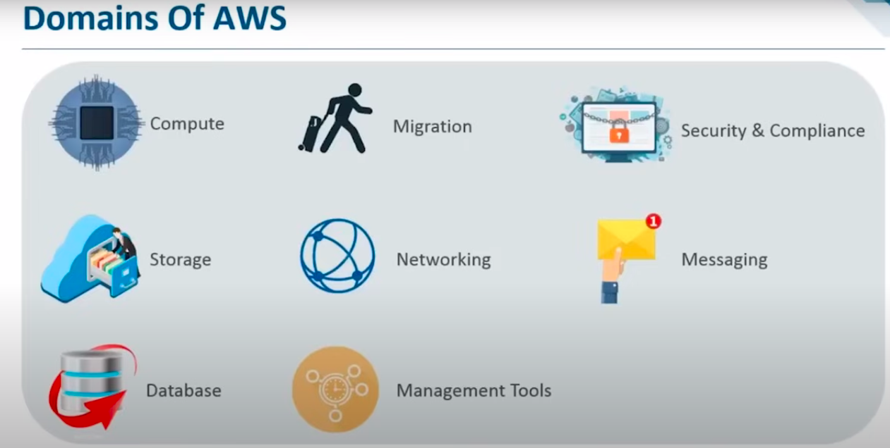

**9. Compute Services --**

**a. What is an instance?**

==> Let’s begin today’s session by discussing what an instance is and how it relates to AWS EC2, which is a core service for us. We’ll explore the different types of EC2 instances, understand how instance pricing models work, and walk through a use case. To wrap things up, we'll have a demo that will guide you through everything we've covered. There's a lot of valuable content to go through today, so let’s dive in and review these topics step by step. First, let's start with the basics.

#### **b. What is EC2?**

#### **What Does "Elastic" Mean?**

Elasticity in the context of EC2 means the service is **resizable** and **reusable**. You can dynamically scale resources up or down based on your needs. This flexibility ensures that you use only the resources required at any given time, making it both efficient and cost-effective. As we explore the demo, you'll see how elasticity works in practice and why it's a key feature of EC2.

### **Key Features of EC2**

1. **Scalability**:
   1. One of the standout features of cloud computing, including EC2, is scalability. Applications can scale up (add resources) or scale down (remove resources) based on demand. For instance, if traffic spikes, your application can automatically scale to handle the load.
   2. EC2 instances are virtual machines. These instances can scale in terms of **memory**, **storage**, and **computation power** to meet your application’s requirements.
2. **Cost Efficiency**:
   1. EC2 allows you to scale resources dynamically, avoiding the need to purchase and maintain fixed hardware.
   2. It offers various pricing models, such as burstable instances and reserved pricing, enabling further cost optimization. These models let you pay only for what you need, significantly reducing expenses compared to traditional IT infrastructure.
3. **Flexibility**:
   1. Combining scalability and cost efficiency makes EC2 highly flexible. You can adapt quickly to changing workloads, ensuring that your applications run efficiently without unnecessary overhead.

### **Instance Types in EC2**

AWS offers different types of instances, categorized into families, each designed for specific use cases. Here's a breakdown:

1. **General Purpose Instances**:
   1. **Use Case**: Balanced performance and cost, suitable for tasks like email response systems.
   2. **Benefit**: Quick response times with cost efficiency.
2. **Compute-Optimized Instances**:
   1. **Use Case**: Applications requiring high computation power, such as analyzing streaming data.
   2. **Example**: Processing live data streams or real-time analytics.
3. **Memory-Optimized Instances**:
   1. **Use Case**: Applications needing large memory capacity for multitasking or intensive processing.
   2. **Example**: A system fetching, processing, and visualizing data simultaneously.
4. **Storage-Optimized Instances**:
   1. **Use Case**: Storing and processing large datasets, such as big data applications.
   2. **Example**: Applications with significant storage demands.
5. **GPU Instances**:
   1. **Use Case**: Graphics-intensive tasks like 3D modeling or rendering.
   2. **Example**: Applications involving heavy graphical processing or machine learning models.

### **EC2 Pricing Models**

To optimize costs further, AWS offers different pricing models:

1. **On-Demand Instances**:
   1. Best for short-term, unpredictable workloads.
   2. No upfront costs; pay-as-you-go pricing.
2. **Reserved Instances**:
   1. Ideal for steady-state workloads.
   2. Offers significant discounts if you commit to using the instance for 1-3 years.
3. **Spot Instances**:
   1. Use spare AWS capacity at up to 90% less cost.
   2. Suitable for flexible workloads that can tolerate interruptions.
4. **Dedicated Hosts**:
   1. Physical servers dedicated to your use.
   2. Useful for meeting compliance requirements or optimizing licensing.

### **Planning is Key**

While EC2 provides a cost-efficient, scalable, and flexible computing platform, effective planning is crucial. Understanding your application's needs and leveraging the appropriate pricing model and instance type ensures you maximize savings and performance.

We are categorizing instances based on their general functionality. What does this mean? Let’s break it down step by step.

### **Burstable Instances**

These are a subset of general-purpose instances designed to start with a **base CPU utilization power**. For example, if you require consistent CPU utilization at a baseline level (say 20%), burstable instances are a great choice.

Here’s how they work:

* Burstable instances operate at a **baseline CPU utilization** but can **burst** to higher levels (e.g., up to 100% CPU utilization) during peak demand.
* For instance, if your website traffic spikes unexpectedly, burstable instances can increase performance temporarily to handle the additional load.
* You are allocated **CPU credits**, which you can use for these bursts. If you don’t utilize all the burstable performance, the unused credits can be saved for future use.

This approach ensures optimized performance during demand surges and helps save costs when traffic is normal.

### **EBS-Optimized Instances**

EBS-optimized instances are designed for applications that require **high-speed data processing**. These instances are particularly useful when:

* Data is continuously flowing into your system.
* You need a fast response time for handling and processing this data.

EBS-optimized instances provide **enhanced input/output operations per second (IOPS)**, ensuring your application can handle the data efficiently.

### **Cluster Networking Instances**

Cluster networking involves grouping multiple instances into **clusters** to serve specific purposes. Each cluster can focus on a distinct function. For example:

* One cluster may handle **high-speed data processing**.
* Another cluster might focus on **storage optimization**.

This setup allows different parts of your application to operate efficiently based on their unique requirements.

### **Dedicated Instances**

Dedicated instances, which we’ve discussed earlier, prioritize **data security**. These are ideal for workloads requiring isolated resources to meet compliance or security standards.

### **Wrapping Up**

These different instance types cater to various use cases, ensuring flexibility, performance, and cost-efficiency. While this overview might feel dense, the upcoming demo will provide a clearer understanding of how these instances function in real-world scenarios. Let’s move forward to explore a practical use case, which will help tie everything together.

### **Use Case: Solving Problems with EC2 Instances**

Let’s explore how EC2 instances can address various challenges effectively. Imagine a scenario where Erica Inc. chooses AWS as their cloud partner and leverages the EC2 service. What kinds of problems could these instances solve? Let’s look at a few examples:

1. **Customer Data Analysis**
   1. **Problem**: Customer data usage fluctuates—sometimes it's high, sometimes low.
   2. **Solution**: **Burstable instances** (a type of general-purpose instance) are ideal here. They can operate at a baseline level during normal usage and scale up during data surges, ensuring efficient performance without overprovisioning resources.
2. **Auto-Response Email System**
   1. **Problem**: Quick response times are needed, but costs should be minimized.
   2. **Solution**: **EBS-optimized instances** with enhanced IOPS (Input/Output Operations per Second) would work best. These instances ensure the speed and reliability necessary for handling a large volume of email responses efficiently.
3. **Search Engine and Browsing**
   1. **Problem**: Handling separate, intensive tasks like search engine indexing and browsing services.
   2. **Solution**: **Clustered network instances** can be deployed, grouping resources specifically for these distinct purposes. For example, one cluster could handle browsing while another focuses on search engine tasks.
4. **Handling Confidential Data**
   1. **Problem**: Data requires high-level security and isolation.
   2. **Solution**: **Dedicated instances** provide a secure environment with isolated resources, making them the ideal choice for processing sensitive information.

### **Summary**

Each type of EC2 instance is tailored to specific workloads, allowing organizations to optimize both performance and cost. This use case illustrates how EC2’s versatility can address diverse business needs efficiently.

### **AWS Compute Domain Overview**

AWS offers various compute services to meet different application needs. The primary services in the **AWS Compute Domain** are **EC2**, **Elastic Beanstalk**, and **AWS Lambda**. Let’s explore each of these:

1. **EC2 (Elastic Compute Cloud)**
   1. EC2 is akin to a raw server—a virtual machine that functions like a remote personal computer.
   2. You have full control over the server, including the ability to install a supported operating system of your choice.
   3. It can be configured for various purposes, such as:
      1. A web server.
      2. A worker node in a distributed system.
   4. EC2 offers flexibility and full customization, making it suitable for environments where granular control is required.
2. **Elastic Beanstalk**
   1. Elastic Beanstalk is an **automated version of EC2** that simplifies application deployment.
   2. While you don’t get direct access to the operating system, you retain control over instance configurations, such as the type of EC2 instance to use.
   3. To deploy an application, you simply upload your code, and Elastic Beanstalk manages the underlying infrastructure for you.
   4. It’s ideal for developers who want a managed platform but still need some control over the application’s environment.
3. **AWS Lambda**
   1. Lambda is an even more abstracted and automated service than Elastic Beanstalk.
   2. With Lambda, you don’t manage the operating system or choose server configurations.
   3. You only upload your code, and it runs automatically in response to events.
   4. It’s designed for use cases like event-driven processing, lightweight microservices, or short-lived tasks.

### **Why AWS Lambda When Elastic Beanstalk Exists?**

While both Elastic Beanstalk and AWS Lambda simplify deployment, their use cases differ significantly:

* **Elastic Beanstalk** is suited for running web applications or services that require a long-running backend infrastructure. You have more control over the configuration compared to Lambda.
* **AWS Lambda** is designed for **serverless** execution, eliminating the need to manage infrastructure entirely. It’s ideal for event-based applications where scalability, cost-efficiency, and simplicity are priorities.

In summary, each service caters to a specific need, giving developers a wide range of options based on their application requirements and desired level of control.

**DEMO-**

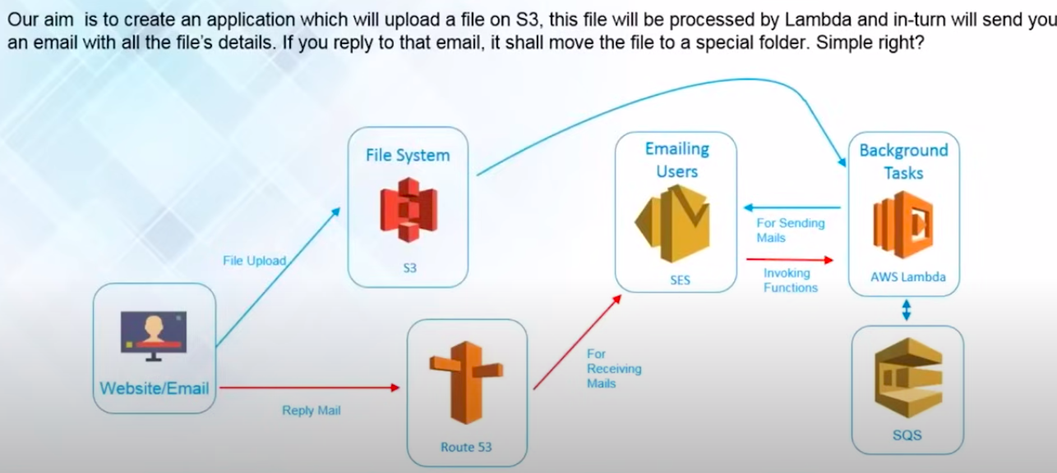

**c. AWS Elastic Beanstalk ?**

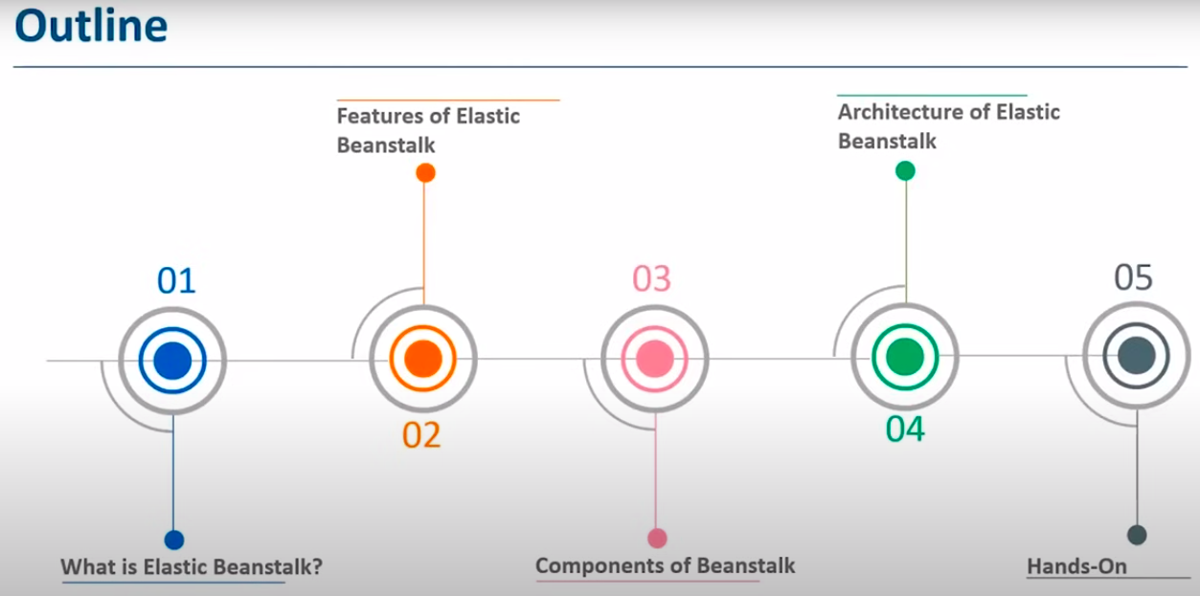

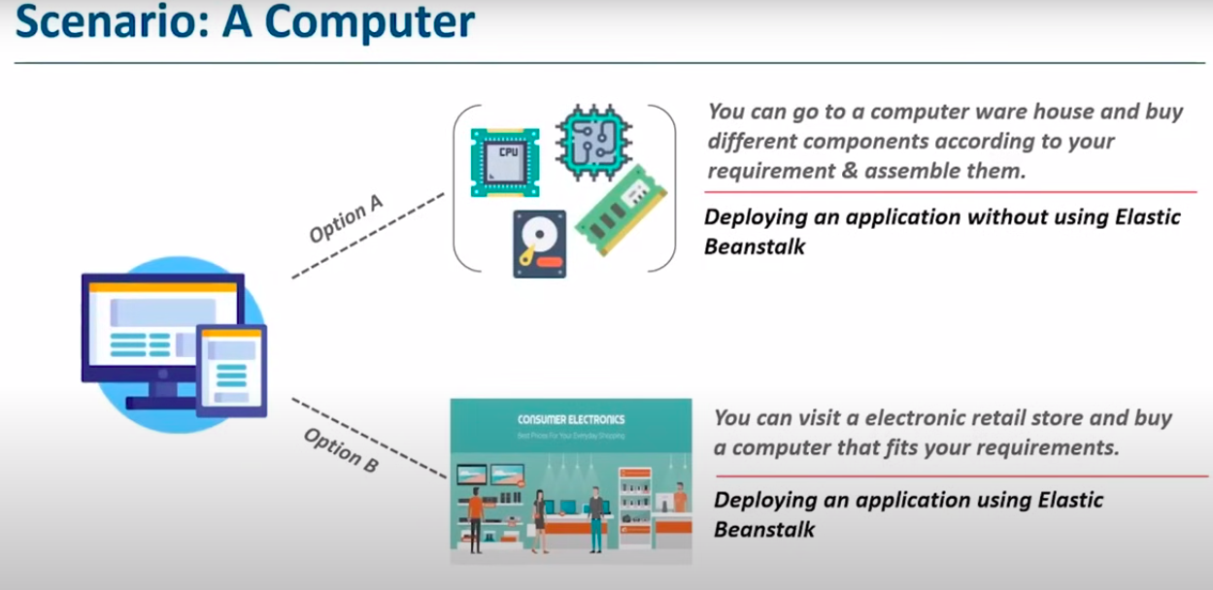

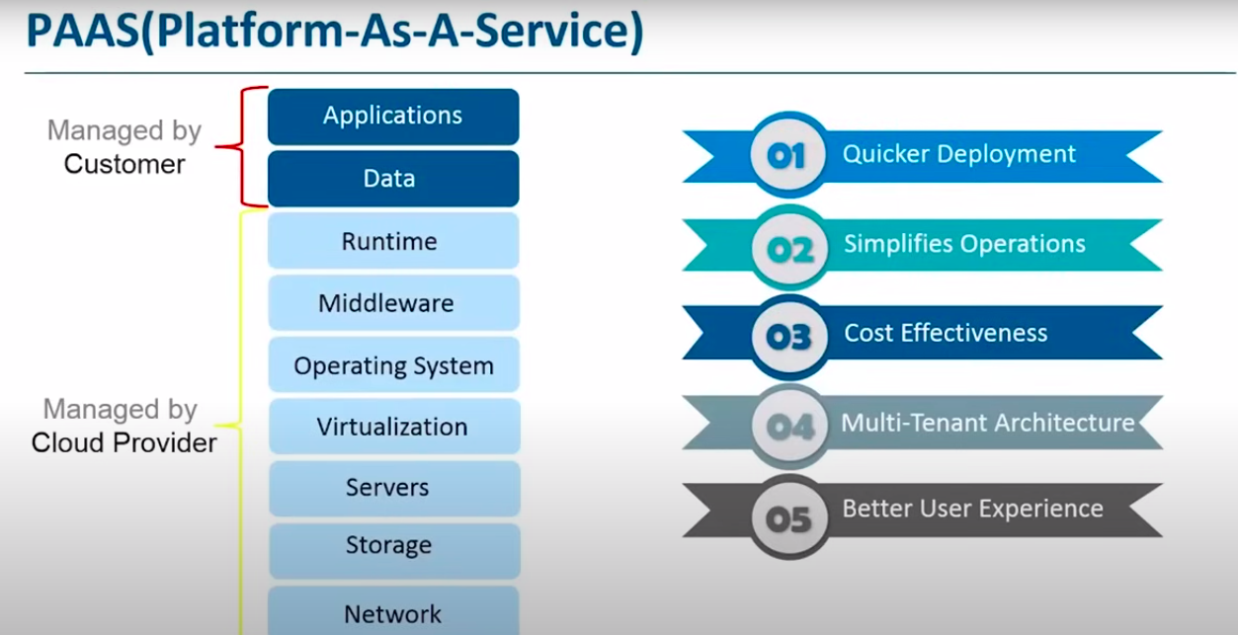

#### **What is AWS Elastic Beanstalk?**

In simple terms, AWS Elastic Beanstalk is a **Platform as a Service (PaaS)** offering from Amazon. It allows developers to deploy and manage applications written in programming languages like **Java, .NET, PHP, Node.js**, and more, on servers like **Apache, Nginx, Passenger**, and **Tomcat**.

If we were to simplify further:

* Elastic Beanstalk automates many of the tasks involved in application deployment, such as provisioning resources, load balancing, auto-scaling, and monitoring.
* Developers focus solely on their **code**, while Elastic Beanstalk manages the underlying infrastructure.

#### **Understanding Elastic Beanstalk Through an Analogy**

Imagine you need a new computer:

1. **Option A:** Build it yourself by sourcing individual components like CPUs, motherboards, and hard drives from a warehouse. You assemble them and configure the system.
   1. This resembles deploying applications **without Elastic Beanstalk**, where you manually manage servers, storage, monitoring, and scaling.
2. **Option B:** Purchase a pre-configured computer tailored to your needs, like one designed for graphic design. You just specify your requirements and start working.
   1. This is akin to using **Elastic Beanstalk**, where most of the backend setup is automated, letting you focus on developing your application.

#### **Definition Revisited**

AWS Elastic Beanstalk is a **PaaS** solution where developers upload their application code, and Elastic Beanstalk handles:

* **Load balancing.**
* **Auto-scaling.**
* **Health monitoring.**
* **Server provisioning.**

#### **Benefits of Elastic Beanstalk (PaaS)**

1. **Quicker Deployment:**
   1. Traditional app deployment requires setting up servers, choosing storage, configuring scaling, and installing monitoring tools—all time-consuming.
   2. With Elastic Beanstalk, developers focus on their code while the platform automates the rest, accelerating deployment.
2. **Simplified Development Process:**
   1. Elastic Beanstalk manages resources like servers, networking, operating systems, and databases.
   2. Developers concentrate solely on application functionality and code.
3. **Cost-Effectiveness:**
   1. Manual deployment often requires additional software for monitoring and security, incurring extra costs.
   2. Elastic Beanstalk bundles these features, reducing unnecessary expenses.
4. **Multi-Tenant Architecture:**
   1. Elastic Beanstalk facilitates secure application sharing across devices.
   2. It also provides detailed reports on application usage and security metrics to ensure data integrity.
5. **User Feedback Integration:**
   1. Elastic Beanstalk allows feedback collection at various stages—design, testing, production—enabling continuous improvement.

#### **Features of Elastic Beanstalk**

1. **Automated Resource Management:**
   1. Automatically scales resources based on application needs.
2. **Customizable Configurations:**
   1. Although it's a PaaS, Elastic Beanstalk allows access to and modification of underlying AWS resources, offering flexibility akin to Infrastructure as a Service (IaaS).
3. **Simplified Monitoring:**
   1. Built-in health monitoring ensures applications perform optimally.

#### **How Elastic Beanstalk Stands Out**

Elastic Beanstalk supports a wide range of programming languages and is suitable for developers seeking a balance between **automation** and **control**. Unlike services like **AWS Lambda**, it provides options to access underlying resources, making it ideal for applications requiring more customization.

#### **Popular PaaS Providers**

Apart from Elastic Beanstalk, other notable PaaS platforms include:

* **OpenShift** (Red Hat)
* **Google App Engine**
* **PythonAnywhere** (Python-based apps)
* **Azure App Services** (Microsoft)

Among these, Elastic Beanstalk offers unique integration with AWS services, making it a go-to choice for hosting applications within the AWS ecosystem.

### **Features of AWS Elastic Beanstalk**

AWS Elastic Beanstalk offers a variety of features aimed at simplifying and accelerating the application deployment process. These include:

1. **Simplified Application Development**

Elastic Beanstalk handles most of the heavy lifting in app deployment. Developers can focus solely on writing code, while tasks like resource allocation, monitoring, and configuration are managed automatically by Elastic Beanstalk.

1. **Automatic Scaling**

Elastic Beanstalk dynamically scales the resources assigned to your application based on its specific needs. This ensures optimal performance during high traffic periods and cost-efficiency during low traffic periods.

1. **Customizable Configurations**

Despite being a Platform as a Service (PaaS), Elastic Beanstalk allows developers to modify pre-assigned configurations, providing flexibility similar to Infrastructure as a Service (IaaS). This feature enables full control over AWS resources, allowing access and adjustments at any time.

### **Fundamentals of Elastic Beanstalk**

To better understand AWS Elastic Beanstalk, let’s explore its key components and architecture:

#### **Components of Elastic Beanstalk**

1. **Application**

An application in Elastic Beanstalk is analogous to a project folder on your computer. It organizes and stores all the components—such as environments, application versions, and configurations—needed for your project.

1. **Application Version**

Each version of your application corresponds to a specific state of your application code. Elastic Beanstalk allows you to upload and manage multiple versions simultaneously, so you can roll back or experiment with updates without losing prior configurations.

1. **Environment**

An environment is the execution space for your application. When launched, it provisions necessary AWS resources (e.g., EC2 instances, Auto Scaling groups, load balancers). A single environment can only run one application version at a time. However, multiple environments (e.g., for development, testing, and production) can coexist for a single application.

1. **Environment Tier**

Elastic Beanstalk offers two environment tiers:

* 1. **Web Server Environment**: Handles HTTP requests.
  2. **Worker Environment**: Handles background processing tasks that are resource-intensive or time-consuming.

1. **Environment Health**

Elastic Beanstalk monitors the health of your environment using a color-coded system:

* 1. **Gray**: Environment is updating.
  2. **Green**: Environment passed health checks.
  3. **Yellow**: Environment failed one or more checks.
  4. **Red**: Environment failed three or more checks.

### **Architecture of Elastic Beanstalk**

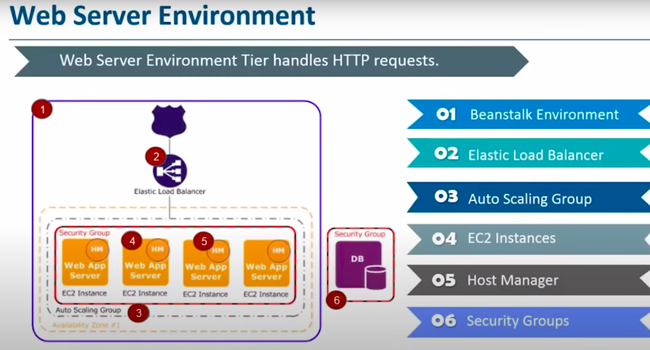

#### **Web Server Environment**

The web server environment handles incoming HTTP requests and includes several components:

1. **Environment**: Manages the runtime for your application.
2. **Elastic Load Balancer (ELB)**: Distributes incoming requests across multiple EC2 instances, ensuring no single instance is overwhelmed.
3. **Auto Scaling Group**: Dynamically adjusts the number of EC2 instances to handle traffic fluctuations.
4. **EC2 Instances**: Host your application. The software stack (e.g., OS, server software) is determined by the container type.
5. **Host Manager**: Runs on each EC2 instance to manage logs, monitor performance, and report metrics to the CloudWatch dashboard.
6. **Security Groups**: Serve as firewalls to control instance access.

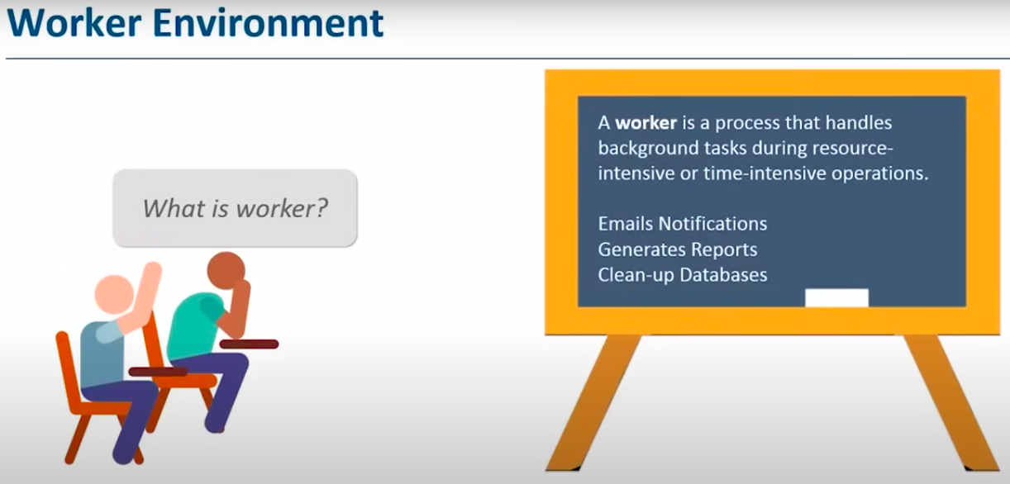

#### **Worker Environment**

The worker environment processes background tasks. Here’s how it operates:

1. **Request Processing**

When the web server environment encounters resource-intensive tasks, it offloads them to the worker environment using Amazon Simple Queue Service (SQS).

1. **Daemon**

A daemon in the worker environment polls messages from the SQS queue and forwards the tasks to the application running in the worker environment for processing.

1. **Task Execution**

The worker environment handles the tasks and sends an HTTP response back to the web server environment upon completion.

By integrating web server and worker environments, Elastic Beanstalk ensures efficient handling of both foreground and background tasks, enhancing performance and user experience.

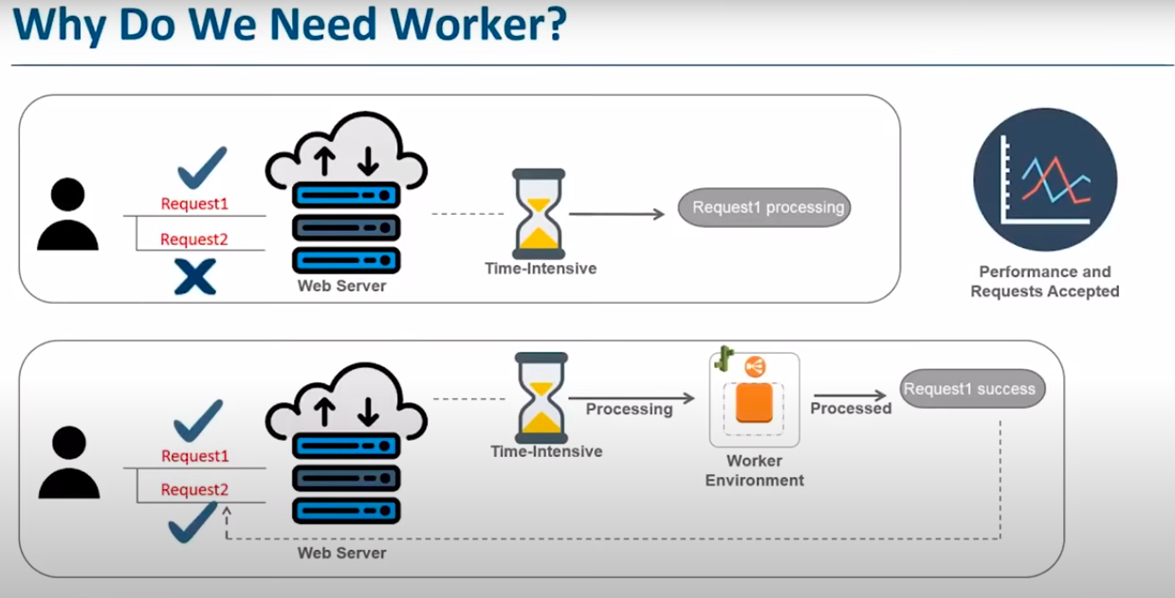

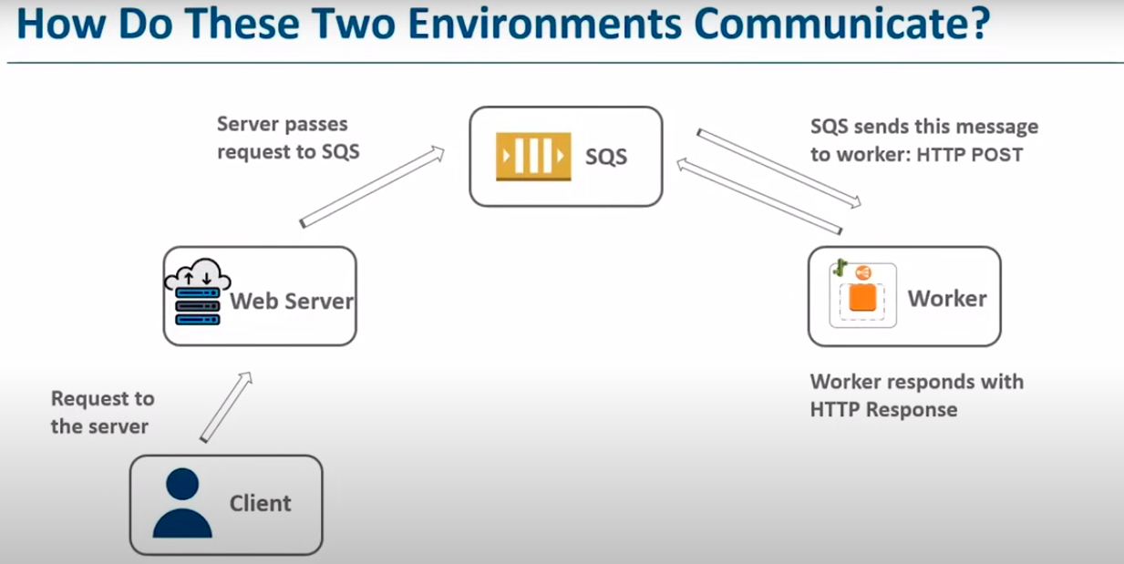

**c. Storage Services -**

### **Understanding Cloud Storage**

Let’s begin by exploring what cloud storage is and address some common myths surrounding it. We'll also review best practices for using cloud storage, examine how various providers operate, and conclude with a demo showcasing how cloud storage services function within Amazon Web Services (AWS).

### **What is Cloud Storage?**

#### **Initial Thoughts**

During a recent set of interviews, many candidates described cloud computing as merely a place to store data online. While this notion is partly correct, it doesn't capture the full scope of cloud storage's capabilities. This session aims to clarify misconceptions and provide a more nuanced understanding of cloud storage.

#### **Basic Definition**

At its core, cloud storage refers to storage made available as a service, accessed over a network. It allows users to store and retrieve data remotely, ensuring accessibility, scalability, and reliability. While this definition is accurate, cloud storage offers much more than just a repository for data.

### **Key Features of Cloud Storage**

1. **Data Storage**

Cloud storage serves as a repository for various types of data, including:

* 1. **Emails**
  2. **Media**: Images, videos, and other files.
  3. **Services**: Hosting websites and applications.

1. **Backup and Recovery**

Large enterprises rely on cloud storage for robust data backup solutions, ensuring secure storage and quick recovery in case of data loss.

1. **Integrated Data Management**

Beyond simple storage, cloud platforms manage data efficiently. This includes integrating data from various sources, processing it, and organizing it for specific use cases.

1. **Smart Storage Capabilities**

Unlike static storage systems, cloud storage is dynamic, enabling actions like:

* 1. **Data Analysis**: Use of big data, business intelligence (BI) tools, and machine learning.
  2. **Marketing Applications**: Leveraging stored data for targeted campaigns.
  3. **Automation**: Supporting AI tools, chatbots, and workflow automation.

### **Cloud Storage and Cloud Computing**

Cloud storage is a subset of cloud computing, which provides a platform for processing, analyzing, and utilizing data. With cloud computing:

* Stored data becomes actionable through services like machine learning and BI tools.
* Businesses can derive insights, find patterns, and optimize operations.
* Platforms allow seamless scaling to accommodate growing or fluctuating data needs.

### **Simplified Understanding**

To sum up, cloud storage:

* Primarily stores data securely and efficiently.
* Offers tools for processing and managing data to meet business requirements.
* Serves as a foundational element of broader cloud computing ecosystems.

As we proceed, we’ll explore specific examples and practices to further illustrate the power and versatility of cloud storage. Finally, we’ll delve into a practical demonstration of how AWS implements cloud storage solutions.

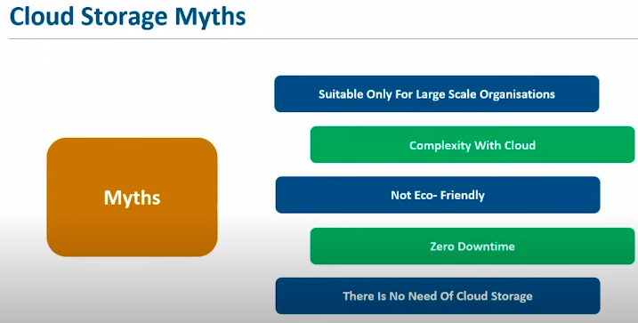

### **Benefits of Cloud Storage**

Let’s explore some of the key benefits of using cloud platforms for data storage. I’ve intentionally saved this discussion for later to better address some of the myths we tackled earlier. These benefits will help clarify how cloud storage works and dispel common misconceptions.

#### **User-Friendly and Scalable**

Cloud platforms are highly customer-friendly. They allow you to:

* Scale storage up or down based on your needs.
* Secure and monitor your data effectively.
* Maintain consistent backups for better data protection.

Additionally, most cloud service providers offer a suite of tools and services to enhance your experience. These services make managing storage seamless and ensure smooth operations on the platform. In our demo session, we’ll dive deeper into just how user-friendly these platforms are.

#### **Enhanced Security**

Security is a top concern for cloud users, and modern cloud storage solutions are exceptionally secure. While skepticism around cloud security was valid when these platforms were new, they are now often more secure than traditional, on-premise systems.

Take **Amazon Web Services (AWS)** as an example. It uses a **shared security model**, where security responsibilities are split between the provider and the customer.

* **Control:** Customers decide what access rights to retain and what to grant to the provider.
* **Durability:** AWS’s **S3 storage service** boasts a durability rate of **99.999999999% (11 nines)**, ensuring your data is reliably protected.
* **Disaster Recovery:** Cloud storage solutions are built for resilience, offering robust disaster recovery capabilities.

#### **Cost-Effectiveness**

Cloud storage operates on a **pay-as-you-go** model, making it highly cost-effective.

* You pay only for the resources you use and for the duration you use them.
* As your storage needs grow, costs per unit of storage often decrease, offering economies of scale.

This pricing model ensures that cloud storage remains pocket-friendly, whether you’re a small user or scaling up to meet enterprise-level demands.

#### **Other Advantages**

Beyond these core benefits, cloud storage also provides:

* **Durability:** Data is redundantly stored across multiple locations.
* **Scalability:** Effortlessly expand or reduce storage capacity as required.

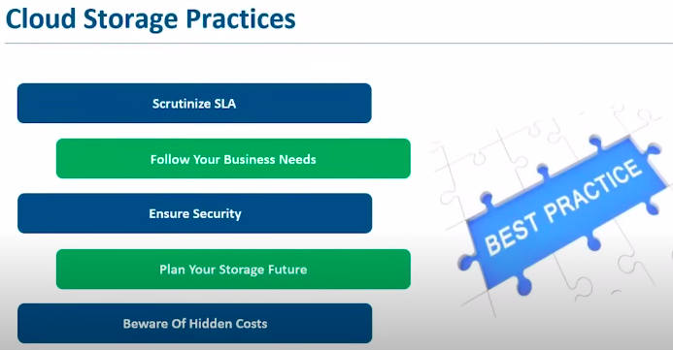

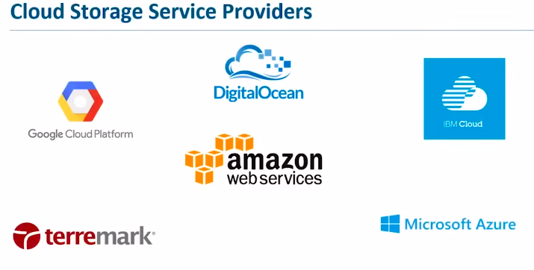

**Cloud Storage Service Providers**

There are several cloud service providers offering storage services, and once we cover them, we’ll move on to the demo part. So, let's take a look at some popular cloud providers.

We have Google Cloud Platform, one of the leaders in the industry, and DigitalOcean, which you’ll often come across in internet ads. TaraMark is another well-known name, and IBM has been in the cloud storage business for a long time. In fact, I recall attending an AWS re:Invent session where the speaker shared a fascinating point: In the 1980s, he visited an IBM facility and saw a massive machine used for storage. This machine, which cost thousands of dollars, could store only 4MB of data. It’s incredible how far storage has come since then.

When we talk about leading cloud providers today, Amazon Web Services (AWS) stands out, with Microsoft Azure catching up. AWS remains far ahead of the competition, but Azure is doing quite well, according to recent statistics.

These providers, including AWS, Google Cloud, and IBM, offer a range of storage services, and today, we'll focus on AWS's offerings. I'll take you through some of their popular storage services and then move into a hands-on demo. Let's dive into the AWS Management Console to explore these services.

**Exploring AWS Free Tier and Storage Services**

When you first sign up with AWS, you'll get a free-tier account, allowing you to use a variety of services free for the first year, with certain usage limits. As long as you stay within those limits, you won’t be charged. The free tier is more than enough for exploring the services if you’re new to AWS. You’ll only need to provide some basic details like your name, work details, and a payment method for verification (but you won’t be charged unless you exceed the free-tier limits). AWS even sends you notifications if you’re close to reaching those limits.

**Navigating the AWS Console for Storage Services**

Let’s now look at some of AWS’s storage services. AWS offers a variety of storage solutions, including:

* **S3 (Simple Storage Service)**
* **EFS (Elastic File System)**
* **FSx**
* **S3 Glacier**
* **Storage Gateway**
* **AWS Backup**

We'll focus on these storage options in more detail, and I'll show you how to use them. Let’s begin by looking at **S3**, which is AWS’s object storage service. It stores data in buckets, and your files are stored as objects within those buckets.

**S3 Tutorial for Beginners**

Amazon S3 allows you to store and retrieve data of any size and type from anywhere via the web or the internet. This is why it’s referred to as an online storage service.

**What are the key features of S3?**

S3 is known for its high durability, offering a durability rate of 99.999999999% (11 nines). This exceptional durability is achieved through continuous checksums that monitor data integrity, ensuring that any corruption is quickly detected and corrected.

Additionally, S3 is highly flexible. It’s simple to use and supports the storage of all types of data. You can store data in any region, and it’s easy to secure your data with various APIs. Its affordability makes it adaptable to different needs.

**Availability and Scalability**

S3 is available across multiple regions, making it highly accessible. I'll demonstrate this shortly in the demo, where we’ll explore how to move and store data in different regions. As for cost, it’s efficient and follows a "pay-as-you-go" model. This means you only pay for the resources you use—whether it’s storage capacity or the time you access the service.

**Cost Efficiency**

While most things in life come with a price, Amazon S3 offers a free tier that allows you to use its services for free for the first year, within certain limits. You can store up to 5GB of data, make 20,000 GET requests, and 2,000 PUT requests. You’re also allowed to transfer 15GB of data out of S3 each month for free. If your usage exceeds the free tier, you will only be charged for the resources you use, making it highly cost-efficient.

**Security**

S3 is secure, offering data encryption on both the client and server sides. You can set up bucket policies to control who has access to your data and what actions they can perform (read, write, etc.). This makes your data safe and protected.

**Buckets & Objects**

S3 operates with the concept of "buckets" and "objects." A bucket is essentially a container for storing data, while an object refers to the actual data file within that container. Each object includes metadata that describes the file, such as the file name (key) and version information.

When you create a bucket, you select a region to store your data. The choice of region impacts both the cost and the latency of data access. For instance, a region far from your users could result in higher latency. Once the bucket is created, you can upload and retrieve data easily using the provided tools.

**Storage Classes**

Amazon S3 provides several storage classes to choose from based on your needs:

* **Standard**: Ideal for frequently accessed data, offering low latency.
* **Infrequent Access**: Suitable for data that is accessed less frequently but still needs to be retrieved quickly.
* **Glacier**: A more affordable option for data that is rarely accessed and stored for long periods, with retrieval times that can take hours.

Each class comes with different pricing and latency options, allowing you to choose the best fit for your needs. For example, Glacier is cost-effective for long-term storage but has a retrieval time of up to 4 hours.

**Conclusion**

Amazon S3 is a flexible, durable, and affordable service that offers secure, scalable data storage options for various use cases. Whether you need to store small files or massive data sets, S3's wide range of storage classes and regions ensure that it can meet your needs efficiently.

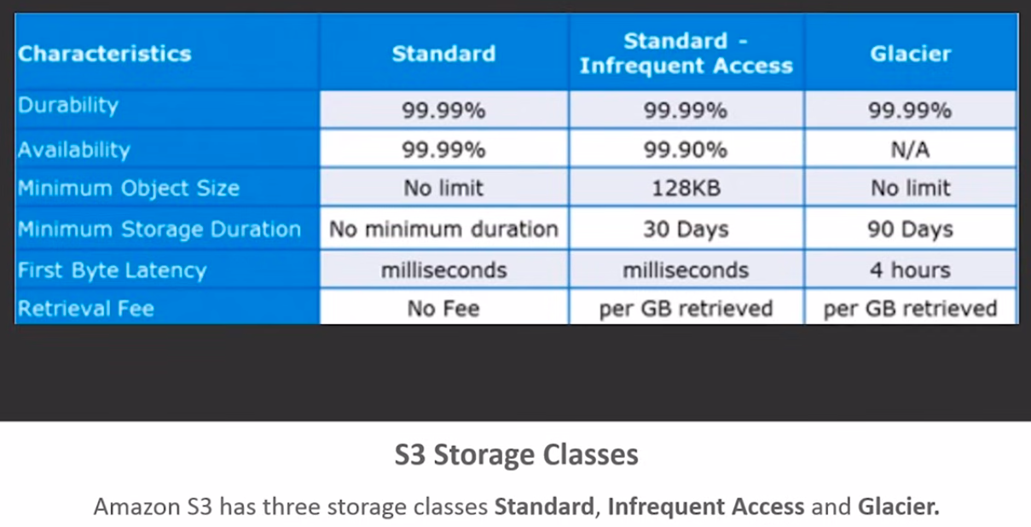

**Versioning & Cross Region Replication**

When we talk about versioning and cross-region replication, we’re discussing methods to ensure the safety and availability of your data. Versioning is all about maintaining multiple copies of your data, and cross-region replication is the process of duplicating that data in a different geographic location.

Why do we need versioning and multiple copies of data? AWS S3 is highly durable and secure, primarily because it allows for error correction and the ability to keep multiple copies of data. If one copy becomes unavailable due to issues with a data center, another copy is accessible in a different region.

**Versioning Explained:** Versioning in S3 helps by creating multiple versions of an object, such as an image or a document. For example, if you store an image in an S3 bucket, you can create multiple versions of it. While the name might remain the same, each version will have a unique version ID. This is especially important when dealing with documents or data files, as versioning helps preserve backups and prevent accidental deletions.

By default, versioning is disabled in S3. To enable it, you need to configure your S3 bucket accordingly. Enabling versioning ensures that objects aren’t overwritten or deleted by mistake. Each time you upload a file with the same name, a new version is created, preserving the previous one. You can retrieve a previous version by specifying its version ID.

For instance, if you update an image, the new version will have a different ID but the same name, preserving the previous image version as well. This also allows you to restore data if you accidentally delete or overwrite a file.

**Cross Region Replication:** Cross-region replication (CRR) in S3 is another key feature. It allows you to replicate data from one S3 bucket in a region to another S3 bucket in a different region. This ensures that your data is geographically distributed, improving availability and fault tolerance.

To set up cross-region replication, you need to create two S3 buckets: one in your source region and another in the destination region. The source bucket’s data can be automatically replicated to the destination bucket. You must enable versioning on both buckets to ensure that data is correctly replicated across regions.

In your AWS account, you can set up cross-region replication by selecting your source and destination buckets and choosing the appropriate replication settings, including the option to change the storage class of replicated objects. This process can also be automated by creating roles with permissions to perform the replication.

**Storage Class Lifecycle Management:** Storage classes, such as Standard, Infrequent Access, and Glacier, offer different levels of data availability and pricing. You can set lifecycle policies to automatically transition objects between these classes based on their usage patterns. For example, after a file has been in the Standard storage class for 30 days, you can move it to Infrequent Access or Glacier if it’s not being accessed frequently. This helps optimize costs without losing access to your data.

Lifecycle management allows you to manage your data's lifecycle automatically, minimizing manual intervention while ensuring data is stored at the most cost-effective class.

**Summary:**

* **Versioning** helps preserve data changes and previous versions, preventing accidental deletions or overwrites.
* **Cross Region Replication** enables the replication of your data across different geographical regions for better fault tolerance and availability.
* **Lifecycle Management** helps automate transitions between storage classes, optimizing costs based on data usage patterns.

This combination of versioning, replication, and lifecycle management helps ensure the durability, availability, and cost-efficiency of your data on AWS S3.

**S3 Transfer Acceleration**

When moving data over long distances, especially from one location far away from you, it's understandable that the transfer may take a while due to the limitations of the internet. The longer the distance, the longer the data transfer. However, with **S3 Transfer Acceleration**, this issue is solved by significantly speeding up the data transfer process.

While other services like **AWS Snowball** and **Snowmobile** can also move data, they physically transport the data and may take several days to deliver. In contrast, **S3 Transfer Acceleration** offers a faster, more efficient method of transferring data. So, how does it work?

### **What is S3 Transfer Acceleration?**

S3 Transfer Acceleration enables fast, easy, and secure transfers of files over long distances between your client and an S3 bucket. This is achieved through **AWS CloudFront** and edge locations. Don’t worry if you’re unfamiliar with CloudFront—I'll explain it soon. First, let’s break it down.

Normally, when you upload data to a distant S3 bucket, the transfer speed can be slow, as you're relying on the internet for communication. However, with Transfer Acceleration, your data is first sent to the nearest **CloudFront edge location**, cached there, and then quickly transferred to the destination S3 bucket. This reduces latency and speeds up the transfer process.

CloudFront works by caching data closer to users. For example, when you search for a URL, the request goes to the server to fetch the data. If the server is far away, it takes longer to retrieve. By setting up edge locations in regions with frequent requests, data can be cached closer to the user, allowing for faster access.

In the case of S3 Transfer Acceleration, your data is uploaded to the nearest edge location, allowing for faster movement to your S3 bucket.

### **Enabling Transfer Acceleration**

Now, let’s take a look at how to enable S3 Transfer Acceleration:

1. Open the S3 console and select the desired bucket.
2. Go to the "Properties" section and enable Transfer Acceleration.
3. Once enabled, you’ll receive an endpoint URL. You can use this endpoint for faster data uploads.

With this enabled, when you upload data to the bucket, the transfer will be much quicker, thanks to the acceleration process.

### **Using Transfer Acceleration Effectively**

Once enabled, you can notice the difference in transfer speed. To see the effects firsthand, you’ll need to use a third-party tool to test the speeds before and after enabling Transfer Acceleration.

Additionally, security plays a big role in managing your data. You can set up **Access Control Lists (ACLs)** and **bucket policies** to control who can access your bucket and what actions they can perform (e.g., uploading, deleting data). For example, if you don’t want a user to delete an object in your bucket, you can write a policy to deny that action, ensuring your data remains secure.

### **Bucket Policies and Access Control**

You can create **bucket policies** to set permissions on your objects, restricting access based on specific actions like deletion or access rights. Here's a simple policy example that denies a user from deleting any objects in your bucket:

{

"Version": "2012-10-17",

"Statement": [

{

"Effect": "Deny",

"Action": "s3:DeleteObject",

"Resource": "arn:aws:s3:::bucket-name/*"

}

]

}

This policy ensures that no one can delete objects in the bucket.

### **Summary**

* **S3 Transfer Acceleration** speeds up data uploads by using CloudFront edge locations.
* You can easily enable Transfer Acceleration in the S3 bucket settings.
* **Bucket policies** and **ACLs** allow you to secure your data and control access.
* Using a third-party tool to test speeds before and after enabling Transfer Acceleration can show the difference.

By using Transfer Acceleration along with proper security controls, you can improve both the performance and safety of your S3 storage.

**Use Case of S3: IMDb Media**

Now, let’s move on to a use case involving IMDb media. For those who watch movies, IMDb is a well-known website that provides detailed information about movies, including actor profiles, reviews, summaries, genres, and more. IMDb also offers its own ratings to help viewers gauge the popularity and quality of a film. Many people trust IMDb's ratings and reviews when deciding whether to watch a movie.

IMDb handles a vast amount of data due to the large number of movies released worldwide. With so many movies listed on IMDb, the database becomes enormous. This presents a challenge: when users search for a movie, the data must be fetched quickly and accurately. The question is: how do you deal with the latency involved in retrieving this information?

### **Solving the Latency Issue:**

IMDb addresses this issue by pre-calculating the search results. Essentially, they create a document for every possible combination of letters that might appear in a search query. For instance, if a user types a 20-character word, there could be over a million possible combinations to consider. Instead of searching through all these possibilities in real-time, IMDb uses pre-calculated documents to instantly return results.

To make this even more efficient, IMDb relies on **S3** and **CloudFront** to speed up data retrieval. **CloudFront**, which caches data at edge locations, ensures that the content is delivered from the nearest location to the user, minimizing latency. When a user searches for a movie, the data is fetched from the nearest CloudFront edge location, which speeds up the process.

### **Handling Massive Data:**

Since IMDb’s database consists of massive amounts of data—hundreds of terabytes—S3 and CloudFront are crucial. S3 stores the vast amount of data, and CloudFront distributes it across edge locations. This setup allows for quicker access and better scalability, even with a growing number of movies and queries.

By using these services, IMDb can efficiently manage huge data sets and provide users with quick, accurate search results.

### **Summary:**

* **IMDb** deals with a massive amount of movie-related data, which must be accessed quickly.
* To reduce latency, IMDb pre-calculates search results and uses **CloudFront** to cache data at edge locations, making it available faster.
* With **S3** and **CloudFront**, IMDb can scale its infrastructure to handle vast amounts of data and ensure low-latency access for users.

In essence, IMDb's use of **S3** and **CloudFront** helps them manage huge data volumes efficiently, while minimizing the time it takes to serve data to users worldwide.

**d. Networking Services**

The networking domain offers three key services: VPC, Direct Connect, and Route 53. Let’s dive into each of them.

1. **VPC (Virtual Private Cloud):**  
   VPC is essentially a virtual network within AWS. When you launch resources within a VPC, those resources can communicate with each other as if they were part of the same network. One important use case for a VPC is when you have a private data center and also use AWS infrastructure. If you want your AWS resources to appear as if they're part of your own network, you can establish a VPN (Virtual Private Network) connection to your VPC. This allows you to securely connect your private network to AWS and access all your AWS resources as though they were in your own data center. VPC provides security, simplifies communication between AWS services, and enables the connection of your private data center to the AWS infrastructure.
2. **Direct Connect:**  
   Direct Connect is a service that provides a dedicated, leased line connection between your data center and AWS, replacing your regular internet connection. If your data transfer needs exceed the bandwidth of a standard internet connection, you can use Direct Connect to establish a private, high-bandwidth line directly to AWS. This ensures faster, more reliable data transfer between your on-premises infrastructure and AWS services.
3. **Route53:**  
   Route 53 is AWS's Domain Name System (DNS) service. The DNS is responsible for translating the URL you enter into an IP address, which directs the request to the server hosting the website or application. When you purchase a domain name, you typically configure name servers within its settings. Route 53 provides the name servers for your domain. Once set up, when a user enters a URL, the request is sent to Route 53. Then, Route 53 directs the request to the appropriate IP address or alias associated with the server hosting your website or application. In short, Route 53 acts as the DNS service that routes traffic from your URL to the correct server IP address.

In conclusion, the networking services offered by AWS—VPC, Direct Connect, and Route 53—play crucial roles in connecting, securing, and routing traffic between your infrastructure and AWS.

**e. AWS CloudFront**

In today's session, we will explore AWS CloudFront. Before diving into the details, let's first take a look at today's agenda. I'll begin by explaining what AWS is, followed by a discussion on why we need AWS CloudFront and its purpose. Next, we’ll explore how content is delivered using Amazon CloudFront and examine its applications. Finally, I’ll wrap up with a demo, focusing on AWS CloudFront distributions.

Let’s begin with the basics: What is AWS?

AWS stands for Amazon Web Services, a leading cloud service provider with the largest market share in the cloud industry. AWS offers over 70 services, and these services are continuously expanding. Some of these services include compute, storage, and database services, all of which are available to you via the cloud. This means you can rent these services and only pay for what you use, based on the duration of usage. If you're interested in learning more about how AWS databases work, I recommend checking out our YouTube channel for detailed videos on AWS topics.

However, for today, let’s focus on AWS CloudFront.

AWS offers various infrastructure and platform-as-a-service options that allow you to host applications or websites online. When you host these applications, one key consideration for the cloud provider is how the data is delivered to your customers. When a user visits a website, they will request certain content, such as images or data. AWS ensures this content is quickly available to users. But how does AWS manage the delivery of this content efficiently?

Let’s break it down with an example:

Imagine you're a user in the USA trying to visit a website hosted on a server in Australia. When you request content, the request travels all the way to the Australian server, and the content is delivered back to you. This process involves multiple network layers, many of which happen behind the scenes. As a result, the delivery of content may not be as fast as you would like.

The situation could be much better if the data were delivered from a location closer to you. In a traditional setup, your request would go to the server in Australia, get processed, and then the content is sent back to you. This process can cause delays, especially if the server is far from your location.

Here’s where CloudFront comes in. Instead of directly sending requests to the distant server, CloudFront caches the data at intermediate locations known as "Edge locations." These Edge locations are distributed across various regions, and when you request content, CloudFront serves the cached content from the nearest Edge location. This significantly speeds up the delivery of data, as the content is fetched from a location closer to you.

How exactly does AWS CloudFront achieve this? Let’s break it down:

1. **Routing:**

CloudFront optimizes how data is routed. Instead of your request traveling to a distant server, CloudFront uses Edge locations closer to you to deliver the data quickly.

1. **Edge Locations:**

CloudFront has a network of Edge locations spread across the globe. These locations cache the content so that when a request is made, the data is delivered faster, improving the overall user experience.

1. **Content Delivery:**

CloudFront supports the delivery of both static and dynamic content, ensuring that all types of data are available to users with minimal latency.

In summary, AWS CloudFront speeds up content distribution by caching data at various Edge locations close to users, ensuring faster content delivery and reducing latency.

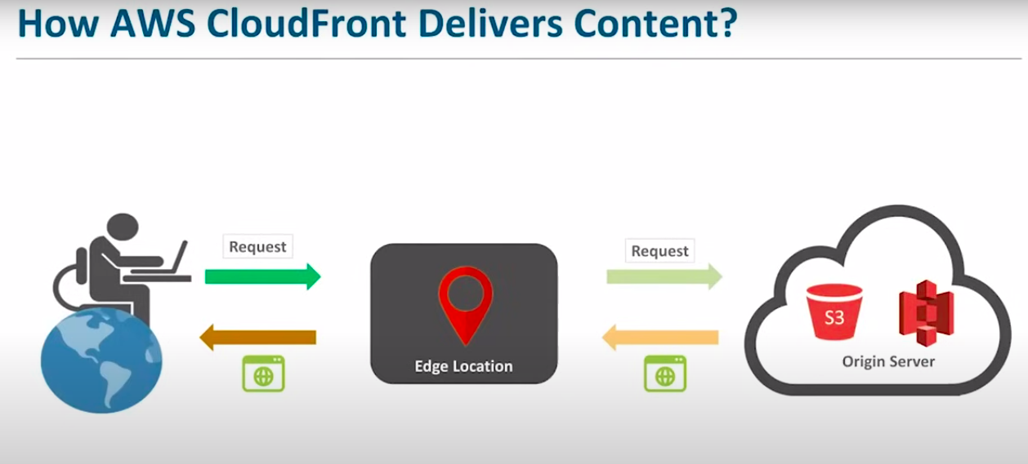

**How AWS CloudFront Delivers Content**

Let’s take a closer look at how AWS CloudFront delivers content. To understand this process, let’s consider a scenario:

Suppose you are a user sending a request to access data that is stored on a server located in Australia. Typically, in a traditional setup, your request would go directly to the server in Australia. However, with AWS CloudFront, the request doesn't go straight to the server. Instead, it first goes to a nearby Edge location. From there, the request is forwarded to the original server.

Here’s how the process works in more detail:

1. If you are in the USA and trying to access data hosted in Australia, your request first reaches a nearby Edge location (a server closer to you).
2. The Edge location checks if the requested data is already cached there. If the data is available in the cache, it is served to you directly.
3. If the data is not cached at the Edge location, the request is sent to the original server in Australia, and the content is delivered back to the Edge location. From there, it is sent to you.

You might wonder, "Why is this process faster than the traditional method?" Here’s the reason:

* In the traditional method, your request travels across several networks to reach the server in Australia, which can cause delays.
* With CloudFront, when the data is cached at the Edge location, the next time you request that data, it’s already available nearby, so it is delivered to you faster.

Additionally, how does CloudFront store content at the Edge location?

* Each Edge location has a regional cache that holds the most frequently requested content for that region. For example, if certain content is requested frequently by users in your area, it will be stored in the regional cache of the nearest Edge location.
* This cache ensures that commonly requested content is delivered more quickly to users.
* If certain content becomes outdated or is no longer requested as frequently, it can be replaced by other content that is more popular.

In summary, AWS CloudFront creates a distribution network with multiple Edge locations, which allows content to be delivered faster by caching data closer to the user and ensuring that frequently requested data is readily available.

**Applications of AWS CloudFront**

Let’s look at some of the key benefits of using AWS CloudFront:

1. **Accelerates Static Content Delivery**: CloudFront enhances the speed of delivering static content like images, as it caches the content at Edge locations closer to the user. This minimizes latency and ensures faster delivery.
2. **Supports Static and Dynamic Content**: CloudFront isn't limited to static content; it can also handle dynamic content like videos or live streams. For example, when a user requests video or live content, CloudFront ensures it streams or delivers that content promptly, with minimal latency.
3. **Secure Content Delivery with SSL/TLS Encryption**: CloudFront allows you to securely access content through HTTPS. It also provides the option to add an additional layer of security by using encryption and key pairs to keep your data secure and private.
4. **Edge Location Customization**: Content that requires customization or processing can be handled at Edge locations rather than on the server. This reduces processing time and enhances performance, saving both time and costs.
5. **Lambda@Edge Integration**: CloudFront integrates with Lambda@Edge, which enables further customization at the Edge locations. This allows you to run code in response to events, offering more control over content delivery.

**Demo: AWS CloudFront Distribution**

Next, I will show you how to create an AWS CloudFront distribution using the AWS console. For those new to AWS, you can create a free-tier account by visiting the AWS website and signing up. Once signed up, you’ll have access to AWS services, including CloudFront, under the free tier, which provides services free for the first year as long as you stay within the usage limits.

For this demonstration, we will create an S3 bucket to store some files and then use CloudFront to distribute that content. Here's how we do it:

1. **Create an S3 Bucket**:
   1. Log into your AWS console, search for "S3," and create a new bucket. Name it appropriately (e.g., bucket-for-aws-demo).
   2. Upload some sample content to the bucket (like an HTML file and an image).
2. **Set Up CloudFront Distribution**:
   1. Go to the CloudFront section of the AWS console and click “Create Distribution.”
   2. Choose the appropriate distribution type. For this case, select “Web.”
   3. Set your S3 bucket as the origin, configure access settings, and ensure that you enable HTTPS for secure content delivery.
   4. Customize caching settings as needed, and create the distribution.
3. **Access the Content**:
   1. Once the distribution is deployed, you'll receive a domain name for accessing the content.
   2. Use the domain name to access the files stored in your S3 bucket, delivered via CloudFront. If you set up the default index file (e.g., index.html), it will load when you enter the domain URL.

By using CloudFront, the content is delivered quickly from the closest Edge location, ensuring faster access for users regardless of their geographical location.

Let’s now move on and create the distribution in the AWS console.

### **AWS CloudWatch**

Today, we will explore **Amazon CloudWatch**, a versatile monitoring tool offered by AWS. Here's what we’ll cover:

1. **What is Amazon CloudWatch and Why Do We Need It?**
2. **Key Concepts of Amazon CloudWatch**
3. **Core Features: CloudWatch Events and CloudWatch Logs**
4. **A Hands-On Demo** to make things more engaging.

Let’s begin by understanding the need for cloud-based monitoring with a few scenarios.

### **Why Do We Need Cloud-Based Monitoring?**

**Scenario 1: Application Performance Issues**

Imagine you’ve hosted a popular messenger app on the cloud. Over time, you notice a steep decline in the number of active users, and you have no clue why.

The reasons could be:

* Your application has a **complex multi-tier architecture**, making manual monitoring of each layer a challenging task.
* You lack a monitoring tool to assess how your application performs on the cloud.

The solution is to use a **cloud-based monitoring tool**. This tool would:

* Provide detailed insights into your application's performance.
* Help you identify areas for improvement.
* Ensure your app meets user expectations, ultimately attracting more users.

**Scenario 2: Reducing Unnecessary Costs**

Consider a project where you’re using **five virtual servers** for heavy computations. These servers are active during the day but underutilized at night, with CPU utilization dropping below 15%. Yet, you pay the same amount 24/7.

Key issues:

* Servers are **underutilized** during idle times.
* You’re paying for unused resources, leading to **higher costs**.

A monitoring tool can address this by:

* Sending alerts when server usage drops.
* Allowing you to schedule server shutdowns during idle times, making the project more cost-effective and avoiding unnecessary expenses.

**Scenario 3: Handling Unexpected Downtime**

Now, suppose you’ve hosted an e-commerce website on the cloud. During a sale, there’s a sudden spike in traffic—great news! But unfortunately, your website experiences downtime. Without a monitoring tool, it’s:

* Difficult to quickly identify and troubleshoot the issue.
* Likely that customers will move to competitors’ sites, causing revenue loss.

With a monitoring tool:

* Errors can be detected and resolved **in real-time**.
* Downtime can be minimized, preventing customer loss.

### **Key Benefits of Cloud-Based Monitoring**

1. **Performance Insights**: Provides detailed reports on your application's performance on the cloud.
2. **Cost Reduction**: Helps optimize resource usage and reduces unnecessary expenses.
3. **Real-Time Error Detection**: Identifies issues early, preventing critical failures.
4. **Enhanced User Experience**: Tracks user interactions to help improve service quality.

### **What is Amazon CloudWatch?**

Amazon CloudWatch is a robust and versatile monitoring tool designed to provide a scalable, reliable, and flexible way to monitor your resources and applications running in the cloud. It offers two levels of monitoring: **Basic Monitoring** and **Detailed Monitoring**.

#### **Basic Monitoring**

* Free for users who sign up for AWS Free Tier.
* Monitors resources at less frequent intervals, approximately every **five minutes**.
* Provides a limited set of metrics for monitoring.

#### **Detailed Monitoring**

* Requires payment based on AWS pricing details.
* Monitors resources more frequently, typically every **minute**.
* Offers a broader range of metrics for in-depth analysis.

### **Key Features of Amazon CloudWatch**

1. **Comprehensive Reporting**: Provides a catalog of standard reports to analyze trends and monitor system performance.
2. **Log Management**: Monitors, stores, and allows access to system and application log files.
3. **High-Resolution Alarms**: Lets you set alarms that send notifications based on specific triggers.
4. **System Events**: Sends system events from AWS resources to services like AWS Lambda and Amazon SNS for automated responses.
5. **Unified Monitoring Console**: Enables administrators to monitor a variety of AWS resources (e.g., EC2 instances, RDS databases, S3 storage, Elastic Load Balancers, Auto Scaling Groups) from a single dashboard.

### **Core Concepts of Amazon CloudWatch**

1. **Metrics**:
   1. Metrics are time-ordered sets of data points that are published to CloudWatch.
   2. Example: Monitoring a variable, like CPU utilization, over time.
2. **Dimensions**:
   1. A dimension is a name-value pair that uniquely identifies a metric.
   2. Example: Monitoring the same metric (e.g., CPU utilization) from two different perspectives, such as instance type or region.
3. **Statistics**:
   1. Aggregations of metric data over specific time periods.
   2. Example: Combining CPU usage data to create a chart for analysis.
4. **Alarms**:
   1. Used to trigger notifications or automate actions when certain conditions are met.
   2. Example: Sending an alert when CPU usage exceeds a specified threshold.

### **How Amazon CloudWatch Works**

1. **Data Collection**:

CloudWatch gathers metrics and logs from AWS resources and applications.

1. **Visualization**:

The collected data is displayed on the CloudWatch dashboard, providing insights into application performance.

1. **Real-Time Monitoring**:
   1. Detects operational changes in your AWS environment.
   2. Automatically responds by triggering actions, such as sending notifications or activating Lambda functions.
2. **Metric Math**:
   1. Combines multiple metrics into a single, unified time series.
   2. Allows you to perform advanced analytics and view results directly on the CloudWatch dashboard.

### **Benefits of Amazon CloudWatch**

* **System-Wide Visibility**: Provides a comprehensive view of your AWS environment.
* **Actionable Insights**: Enables you to monitor application performance and identify areas for improvement.
* **Resource Optimization**: Helps optimize resource utilization to reduce costs.
* **Operational Health Overview**: Offers a unified view of your environment’s health to ensure everything runs smoothly.

By integrating these features and concepts, Amazon CloudWatch ensures real-time monitoring, proactive issue resolution, and efficient resource management for your AWS ecosystem.

### **AWS CloudFormation**

Today, we will explore AWS CloudFormation, a powerful service that simplifies the management and deployment of AWS resources. Let’s dive into the agenda for this session:

1. **Why Do We Need AWS CloudFormation?**
2. We'll begin by understanding the need for CloudFormation and how it solves critical challenges.
3. **What is AWS CloudFormation?**

Next, we’ll cover the core functionality and benefits of this service.

1. **Getting Started with AWS CloudFormation**

We’ll discuss the prerequisites for using CloudFormation, focusing on the creation and use of JSON templates.

1. **Understanding JSON Templates**
   1. First, we’ll explore the structure of a JSON document.
   2. Then, we’ll analyze a sample JSON template to see how it works.
2. **Hands-On Demonstration**

We’ll wrap up the session with two demonstrations:

* 1. A basic example to introduce you to CloudFormation’s capabilities.
  2. A more advanced use case to showcase its versatility.

### **Why Do We Need AWS CloudFormation?**

Imagine you have an application that relies on multiple AWS resources. Deploying and managing each resource individually can be time-consuming and complex. To streamline this process, AWS offers **CloudFormation**, a service that allows you to manage, create, and provision all resources from a single interface.

Instead of manually configuring resources, CloudFormation automates the process, enabling you to focus on your application rather than the underlying infrastructure.

### **What is AWS CloudFormation?**

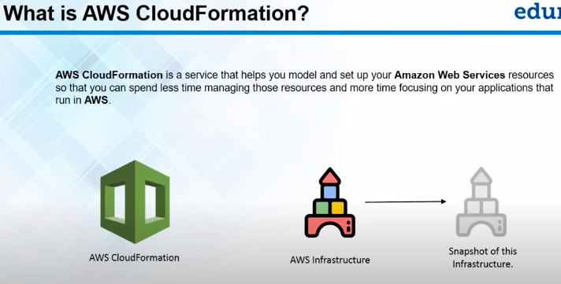AWS CloudFormation is a service that helps you model and set up AWS resources efficiently. By using CloudFormation, you can:

* **Quickly build applications** without the repetitive task of setting up resources manually.
* **Create reusable templates** to define your resources and their dependencies.

Using **CloudFormation Designer**, you can visually design your infrastructure, define the relationships between resources, and save your design as a template.

#### **Why Use Templates?**

Templates make replication and scaling seamless. For example:

* If you need your application to run in multiple regions for backup purposes, you don’t have to configure resources individually in each region.
* Simply use your saved template to deploy the same configuration across multiple regions.

Benefits of templates include:

1. **Precision**: Ensures identical resource setups across all deployments.
2. **Efficiency**: Saves time by eliminating repetitive tasks.

### **Getting Started with AWS CloudFormation**

To use CloudFormation effectively, you’ll need a JSON template that outlines your desired resource configuration.

#### **Understanding JSON Templates**

1. **Structure**: Learn the layout and components of a JSON template.
2. **Sample Template**: Analyze a real-world example to see how resources and dependencies are defined.

### **Demonstration**

1. **Basic Demo**: A simple walkthrough to get started with CloudFormation.
2. **Advanced Demo**: A deeper dive into creating complex resource setups and managing dependencies.

### **Summary**

AWS CloudFormation is a powerful tool that simplifies resource management and deployment. It allows you to:

* Focus on application development by automating resource provisioning.
* Replicate configurations across regions with precision and speed.
* Utilize reusable templates for consistency and scalability.

By mastering CloudFormation, you can significantly enhance your efficiency and streamline your AWS operations.

### **Getting Started with AWS CloudFormation**

Let’s explore how you, as a user, can effectively leverage AWS CloudFormation to create and manage resources.

#### **Step 1: Using a JSON Script**

To use AWS CloudFormation, the first requirement is a JSON script. Here's why:

* The JSON script serves as a template to define your infrastructure.
* When you use the **CloudFormation Designer**, you can drag and drop AWS resources. In the background, this process automatically generates a JSON script.

Alternatively, if you’re proficient with JSON, you can create your own script manually. Either way, this script forms the backbone of your CloudFormation template.

#### **What is a JSON Script?**

A JSON (JavaScript Object Notation) script is:

* A human-readable, open-standard format used to define data structures.
* Easy to understand, even without extensive programming knowledge.

When using CloudFormation, the Designer tool helps you visually create a template, and it automatically generates the corresponding JSON script for you. If you prefer, you can also edit or create the script manually and upload it into the Designer.

#### **JSON Document Structure**

A CloudFormation JSON document follows a specific structure with these key fields:

1. **Template Format Version**: Specifies the version of the template format.
2. **Description**: A text field that briefly explains what the template does.
3. **Metadata**: Includes properties related to the template.
4. **Parameters**: Defines values you need to pass into the template, such as configuration details.
5. **Mappings**: Specifies relationships and dependencies between AWS resources.
6. **Conditions**: Defines conditions under which resources are created or updated.
7. **Outputs**: Lists the results or outputs generated by the template, such as resource IDs or URLs.
8. **Resources**: The main field where you define AWS resources, including their types and configurations.

#### **How JSON Works in Practice**

The most significant part of the JSON script is the **Resources** section. This is where you specify the AWS services you want to deploy, their configurations, and dependencies. For example, creating an S3 bucket involves:

* Specifying the **name** of the bucket.
* Declaring the **type** of the resource (e.g., S3 bucket).

#### **Demonstration 1: Creating an S3 Bucket**

Using the CloudFormation Designer:

1. Drag and drop the S3 service into the workspace.
2. Edit the bucket name, such as MyCloudFormationBucket.
3. The Designer automatically generates the corresponding JSON script, which can be used to create a stack.
4. Click **Create Stack**, name your stack, and deploy it.

**Result**: The S3 bucket is created, and its creation is reflected in the S3 service console.

#### **Demonstration 2: Launching a LAMP Stack**

For a more complex example, consider deploying a **LAMP stack** (Linux, Apache, MySQL, PHP):

1. Use a sample template in AWS CloudFormation.
2. Customize the parameters (e.g., database name, user, password).
3. Deploy the stack to launch an EC2 instance, install the necessary software, and configure MySQL.

**Steps to Verify**:

* SSH into the EC2 instance.
* Check the MySQL installation and confirm that the database and user configurations match the JSON template parameters.

#### **Key Benefits**

* **Automation**: Simplifies resource creation and reduces the need for repetitive tasks.
* **Reusability**: Templates can be reused across multiple regions or accounts.
* **Precision**: Ensures consistent deployment configurations.
* **Scalability**: Quickly replicate infrastructure with minimal effort.

AWS CloudFormation gives you granular control over your AWS infrastructure through simple, reusable JSON scripts, enabling efficient and accurate deployments.

### **Snapshots & AMIs**

Let’s start by understanding what Snapshots and AMIs are. Most of you are probably familiar with EC2 instances, but for those who aren’t, here’s a quick overview:

An **EC2 instance** is like a fresh, brand-new computer. It comes with a blank slate, and you can choose which operating system (OS) to install. Once the OS is set up, you can install any software you need.

However, if you need multiple EC2 instances with the exact same configuration—say, five servers with identical setups—doing this manually for each instance (installing the OS and configuring software every time) can be tedious and time-consuming.

#### **The Solution: Snapshots and AMIs**

To simplify this process, AWS provides two powerful features: **Snapshots** and **AMIs (Amazon Machine Images)**.

1. **What is an AMI?**
2. An **AMI** is a bootable image of an EC2 instance. Think of it as a pre-configured template that includes your operating system, installed software, and specific settings. Once you’ve set up an EC2 instance exactly how you want it, you can create an AMI from it. You can then use this AMI to launch multiple EC2 instances with the same configuration.
3. **What is a Snapshot?**

A **Snapshot** is a backup of the data stored on the instance’s hard drive. Imagine you have a "C drive" on your computer, and you make a copy of it onto an external drive. That copy is a snapshot. However, a snapshot by itself is not bootable—it’s just a backup of your data.

When you take this snapshot and package it with the operating system and configuration settings, it becomes an **AMI**—a bootable image that can launch new instances.

#### **Key Difference**

* A **Snapshot** is a non-bootable backup of your data.
* An **AMI** is a bootable image that replicates the entire configuration of your EC2 instance.

With Snapshots and AMIs, you can avoid repetitive configurations and deploy identical servers quickly. This is especially useful when scaling up your resources or preparing for failovers.

### **Why Auto Scaling?**

Let’s break this down step by step. First, I'll explain the concept, and then I’ll demonstrate it on the AWS console.

#### **Creating an AMI Recap**

Previously, we discussed **AMIs (Amazon Machine Images)** and learned how to create them from existing EC2 instances. AMIs allow us to replicate a server’s setup, including all installed software and configurations. For example, if you have a server hosting a website, you can create an AMI from it. When you launch new instances from this AMI, they’ll replicate the original server, complete with the website setup.

Now that we’ve created AMIs for two servers (e.g., *Server 1* and *Server 2*), let’s explore **why we need auto scaling** and how it relates to AMIs.

#### **The Need for Auto Scaling**

Imagine you’ve deployed a website on a server. This server is essentially a computer with limited resources, such as an **8GB RAM** and a **quad-core processor**. Let’s say this setup can handle traffic from **100 users** seamlessly.

However, what happens if your website becomes an overnight success and **300 users** try to access it simultaneously?

1. The server becomes overwhelmed.
2. The website may slow down or crash, leading to a poor user experience.

To handle this sudden surge in traffic, you’d need to add more servers to share the load. Manually deploying additional servers is time-consuming and prone to errors.

This is where **Auto Scaling** comes in.

#### **What is Auto Scaling?**

Auto Scaling is a service that:

1. **Monitors your server’s load** (e.g., CPU utilization, network traffic).
2. **Automatically adjusts the number of servers** based on traffic demands.

For example:

* If traffic spikes and your server can’t handle it, Auto Scaling will launch additional servers.
* When traffic decreases, it scales down by terminating unnecessary servers, saving costs.

#### **How AMIs and Auto Scaling Work Together**

When Auto Scaling launches new servers, it needs to create them based on a **template**. This is where **AMIs** are crucial:

1. The AMI ensures that every new server is an **exact replica** of the original, with the same configurations and software.
2. For example, if your original server hosts a website, every new server launched by Auto Scaling will also have that website ready to go.

#### **Scaling in Both Directions**

Auto Scaling doesn’t just scale **up** when traffic increases; it also scales **down** when traffic decreases. For example:

* If the average CPU utilization drops below 20%, Auto Scaling can terminate some servers to reduce costs.
* This dynamic adjustment ensures you’re using only the resources you need.

#### **Auto Scaling Demonstration**

1. **Launch Configuration:**
   1. Specifies the type of EC2 instance (e.g., t2.micro) and the AMI to use.
   2. Defines the base template for servers launched by Auto Scaling.
2. **Auto Scaling Group:**
   1. Defines the conditions for scaling up or down (e.g., CPU utilization > 70%).
   2. Specifies the minimum and maximum number of servers to maintain.

Using the AWS console, I configured Auto Scaling Groups for both **Server 1** and **Server 2**. These groups:

* Monitor traffic and CPU utilization.
* Ensure at least one instance is always running.
* Automatically launch or terminate instances as needed.

#### **Why Do We Need a Load Balancer?**

Once multiple servers are running, you need a way to distribute incoming traffic evenly among them. This is where a **Load Balancer** comes into play.

* A Load Balancer ensures that traffic is distributed efficiently across all servers in an Auto Scaling Group.
* Without it, traffic might overload one server while others remain idle.

Let’s now dive into the concept of **Load Balancers** and their role in managing distributed traffic.

### **What is a Load Balancer?**

A **Load Balancer** is a device or service that acts as a traffic manager for your application or network. It distributes incoming traffic across multiple servers to ensure no single server is overwhelmed, improving application availability, reliability, and performance. Here's how it works:

1. **Traffic Distribution**: When users send requests to your application, they first reach the load balancer. The load balancer evaluates which server in the backend has the least load or is most suited to handle the request.
2. **Server Selection**: Based on server health and traffic rules, the load balancer forwards the request to the appropriate server. This can be done in two primary ways:
   1. **Equal Distribution**: Traffic is equally spread across all servers in the backend.
   2. **Conditional Routing**: Requests are routed based on specific rules, such as the content of the request.

### **Types of Load Balancers**

1. **Classic Load Balancer (CLB)**:
   1. Distributes traffic equally across all servers.
   2. Does not allow routing based on specific request characteristics.
   3. Suitable for simpler use cases.
2. **Application Load Balancer (ALB)**:
   1. Provides advanced routing based on the content of requests.
   2. Allows you to route traffic to different backend servers or groups based on URL paths, hostnames, or other conditions.

### **Example Use Case with Application Load Balancer**

Imagine a scenario where your application has two main services:

* **Image Processing Service** hosted on one set of servers.
* **Blogging Service** hosted on a different set of servers.

Using an **Application Load Balancer**, you can:

* Route requests with the path /image to the image-processing servers.
* Route requests with the path /blog to the blogging servers.

This setup ensures that traffic is directed to the correct service while maintaining scalability and efficiency.

### **Setting Up an Application Load Balancer on AWS**

1. **Create the Load Balancer**:
   1. Select **Application Load Balancer**.
   2. Choose an internet-facing or internal load balancer based on your use case.
   3. Configure listeners (e.g., HTTP or HTTPS).
   4. Select availability zones for redundancy.
2. **Define Target Groups**:
   1. Each target group corresponds to a specific set of backend servers (e.g., image-processing servers or blogging servers).
3. **Set Rules**:
   1. Configure routing rules based on paths or hostnames (e.g., /image goes to the image-processing target group).
4. **Associate Auto-Scaling Groups**:
   1. Attach auto-scaling groups to target groups to ensure your system can handle varying loads.
5. **Test Your Configuration**:
   1. Access the load balancer URL with different paths to ensure traffic is routed to the correct servers.

### **Real-World Benefits**

* **Scalability**: Supports auto-scaling to handle increased traffic.
* **Fault Tolerance**: Redirects traffic from unhealthy servers to healthy ones.
* **Improved Efficiency**: Routes traffic based on request type, ensuring optimal server usage.

This is how a load balancer simplifies traffic management and enhances the reliability of your application!

**f. Cloud Security -**

* We’ll start by discussing the **why** and **what** of cloud security.
* Next, we’ll explore how to choose between a **public, private**, and **hybrid cloud**.
* We’ll then address whether cloud security is a real concern for companies planning to move to the cloud.
* Once we understand the importance of cloud security, we’ll look at **how secure** your application should be.
* We’ll also go over the **process of troubleshooting cloud security threats**.
* Finally, we’ll implement this process using **AWS**.

Now, let’s begin with our first topic: Why is cloud security important? To illustrate this, let’s take a look at three well-known companies: LinkedIn, Sony, and others.

### **Why is Cloud Security Important?**

In 2012, LinkedIn suffered a major cyberattack, where hackers exposed 6.5 million usernames and passwords. Soon after, Sony became a victim of one of the most aggressive cyberattacks in history, with hackers leaking highly sensitive data, including financial details and upcoming movie projects, significantly impacting its business operations. Similarly, Apple’s iCloud faced a breach that led to the exposure of private user photos.

These incidents highlight critical security vulnerabilities, making it evident that robust cloud security is essential in the world of cloud computing.

### **What is Cloud Security?**

Cloud security involves leveraging advanced technologies and programming techniques to protect applications, data, and cloud-related infrastructure. Since new threats and workarounds emerge daily, security measures must be continuously updated to tackle evolving challenges effectively.

### **Choosing Between Public, Private, and Hybrid Clouds**

Understanding the security requirements of different cloud infrastructures is crucial:

* **Private Cloud**: Best for storing highly confidential files. This can involve hosting private servers internally or using dedicated servers provided by a cloud vendor.
* **Public Cloud**: Ideal for non-sensitive data or public-facing applications, such as product pages or download links, where confidentiality is not a priority.
* **Hybrid Cloud**: Combines the strengths of both private and public clouds. Sensitive data can be stored in a private infrastructure, while less critical data or applications are hosted on the public cloud. This offers both enhanced security and cost efficiency.

### **The Growing Importance of Cloud Security**

Security and privacy are top concerns for organizations moving to the cloud. According to Gartner research, companies often hesitate to migrate due to apprehensions about securing cloud environments. This reinforces the significance of adopting strong cloud security practices.

### **Balancing Security and User Experience**

Cloud security is a blend of science and art:

* **Science**: Involves designing and implementing technical solutions to protect data and applications.
* **Art**: Requires balancing security measures with user convenience to avoid hindering the user experience. For instance, while two-factor authentication enhances security, overly frequent password prompts might frustrate users.

An effective security strategy combines creativity and technical expertise to ensure robust protection without compromising usability.

### **Moving Forward**

To address cloud threats, organizations must adopt proactive security measures and continuously adapt to emerging risks while keeping user experience in mind. By understanding cloud security fundamentals, organizations can choose the right infrastructure and strategies to safeguard their data and applications.

### **How to Troubleshoot a Threat in the Cloud?**

Let’s say you’re using Facebook and receive a random message from someone claiming something unusual has happened, with a link to click for more details. By mistake, you click the link, not realizing it’s spam. As a result, all of your Facebook friends receive that same message, and they get frustrated with the spam filling up their inboxes. You get worried and upset, so you contact Facebook to report the issue. They inform you that they’re already aware of the problem and are working on it. But how did Facebook identify the issue so quickly?

Cloud security typically involves a three-stage process for troubleshooting threats:

1. **Monitoring Data**: AI algorithms are used to track what normal system behavior looks like. Any deviation from this baseline triggers an alarm. Cloud security experts then monitor this alarm to detect potential threats.
2. **Gaining Visibility**: Once a threat is identified, experts need to understand what caused it or who is responsible. They use specialized tools to examine the data and pinpoint the event or activity that triggered the problem.
3. **Managing Access**: After identifying the source of the threat, cloud security experts assess who had access to the system. They can then isolate the user responsible for the issue and, if necessary, remove them from the system to prevent further damage.

Now, let's look at how we would implement these stages in AWS.

### **Cloud Security in AWS**

The first stage of cloud security is **monitoring data**. If you're using AWS and encountering issues, how do you monitor the data? AWS provides a service called **AWS CloudWatch**, which is a monitoring tool that allows you to track various AWS resources, including EC2 instances. Through CloudWatch, you can monitor network traffic, incoming and outgoing data, and set alarms for deviations from normal behavior. For example, if something unusual happens, CloudWatch will trigger an alarm to alert you, allowing you to investigate and resolve the issue.

Here’s a quick demo of how CloudWatch works:

1. Go to the **CloudWatch** dashboard from the management tools in AWS.
2. Under **Metrics**, you can monitor your EC2, EBS, and S3 resources.
3. For instance, you can select an EC2 instance, like "WPS Instance," and view metrics such as "Network In" or "Disk Read Ops."
4. You can set up alarms that notify you if the metric exceeds a defined threshold.

For example, if there’s a spike in network traffic, the metric graph will show you the increase, allowing you to respond accordingly.

In CloudWatch, you can also configure alarms to notify you via **SNS (Simple Notification Service)**, which we’ll discuss in detail later. Additionally, you can link alarms to **Lambda functions** that automatically take actions, such as clearing background processes when CPU usage exceeds a threshold.

Next, let's look at **gaining visibility**. AWS provides **CloudTrail**, a logging service that tracks API calls and logs events, providing full visibility into the activity in your AWS account. For example, if a hacker gains access to your system, CloudTrail logs every action taken, including the time and origin of each request. You can use CloudTrail logs to trace the attacker’s movements and pinpoint when and how they accessed your system.

To use CloudTrail:

1. Navigate to **CloudTrail** in the AWS management console.
2. Here, you can see logs for every action, such as logging into the console, deleting S3 buckets, etc.

This detailed logging helps you track malicious activity and identify responsible parties, much like identifying the source of spam messages in our Facebook example.

The final stage is **managing access**. Once you’ve identified the issue, you need to manage access to your system. In AWS, this is done using **IAM (Identity and Access Management)**. IAM allows you to grant granular permissions to users, ensuring they only have access to the resources they need. If a user is responsible for triggering a security issue, IAM allows you to revoke their access and secure your system.

Here’s how to manage access with IAM:

1. Go to the **IAM** dashboard in AWS.
2. You can create **roles** and assign specific permissions to users. For instance, if a user is responsible for an issue, you can revoke their session or modify their role to restrict access.
3. You can also create new roles with specific permissions, ensuring users have only the access they need to perform their tasks.

With IAM, you can securely manage access and ensure that only authorized individuals can access your AWS resources.

In summary, **CloudWatch**, **CloudTrail**, and **IAM** are essential tools for monitoring, gaining visibility, and managing access in AWS to secure your cloud infrastructure.

**AWS Identity and Access Management (IAM)**

Let’s begin today’s session by understanding why **Access Management** is crucial. Imagine you have a company with a server housing all resources—files, databases, applications, etc. You need to ensure that users only access what’s necessary for their role. For example:

1. **Administrator**: Requires full access to manage the server.
2. **UI Developer**: Only needs access to graphical tools but not to sensitive folders or internet.
3. **Business Analyst**: Requires analytics tools but shouldn’t see development modules.

This principle of granting limited and specific permissions is the foundation of **Access Management**. AWS simplifies this with its **IAM service**, allowing you to manage access effectively within a single AWS account.

### **What is AWS IAM?**

AWS IAM is a service for managing access to your AWS resources by defining who can access what. A single AWS account can host multiple users, each with tailored permissions based on their roles:

* Developers can be restricted to EC2 instances.
* Database Administrators (DBAs) might only access RDS databases.

IAM does more than just creating users—it involves policies, roles, and groups to manage permissions dynamically.

### **IAM Components**

AWS IAM has four key components:

1. **Users**:

Users represent individuals requiring access. When you create an AWS account, it starts as a **root account** with unrestricted access. However, you should avoid using the root account for everyday operations. Instead, create an **Administrator user** and assign specific permissions to it.

Example:

* 1. **Administrator User**: Full access to all AWS resources.

1. **Groups**:

Groups simplify permission management for multiple users with similar roles. Instead of attaching policies individually to each user, you assign a policy to the group.

Example:

* 1. A **Development Group** with EC2 access.
  2. A **Finance Group** with access to billing and cost management.

1. **Roles**:

Roles provide permissions to AWS resources or applications, not people. For instance:

* 1. An EC2 instance hosting an application may need access to S3 buckets. You can create a role allowing S3 access and assign it to the EC2 instance.

1. **Policies**:

Policies define permissions (e.g., "allow full access to S3"). Policies can be attached to users, groups, or roles.

### **Practical Example**

Let’s consider a practical scenario:

1. **Creating an Administrator User**:
   1. Use the IAM console to create a user.
   2. Assign **AdministratorAccess** policy.
   3. Generate an access key and secret for programmatic access.
2. **Managing Groups**:
   1. Create a **Development Group**.
   2. Attach an S3 access policy to the group.
   3. Add users to the group.
3. **Assigning Roles**:
   1. Create a role with S3 access.
   2. Attach it to an EC2 instance hosting your application.
4. **Custom Policies**:
   1. Use the IAM Policy Generator or JSON editor to create tailored permissions.

**Key Best Practices**:

* **Avoid Root Account Usage**: Use it only for emergencies.
* **Enable MFA**: Add Multi-Factor Authentication for enhanced security.
* **Follow the Principle of Least Privilege**: Grant only the necessary permissions to each user or role.

### **Amazon Redshift Overview**

Amazon Redshift is a **cloud-based data warehouse service** provided by AWS. It is a **fast, scalable, and cost-effective solution** for analyzing large volumes of data across **data warehouses** and **data lakes**.

Today, I’ll introduce you to Redshift’s key concepts, architecture, and benefits. Some terms may appear highlighted on the screen—don’t worry about them now. We’ll discuss their meaning as we progress.

### **Key Concepts in Amazon Redshift**

#### **1. Architecture**

Amazon Redshift operates as a collection of compute resources called **nodes**, which are organized into groups called **clusters**. Each cluster runs the Amazon Redshift engine and contains one or more databases.

* **Leader Node**: Manages client queries. It parses queries, creates an execution plan, and coordinates with compute nodes to execute the plan. Once the execution is complete, it aggregates the results and sends them back to the client.
* **Compute Nodes**: Execute the query plan developed by the leader node. These nodes communicate with one another during execution. Each compute node is further divided into **node slices**, which process data in parallel for better performance.

#### **2. Interaction with Client Applications**

Client applications (like **BI tools**) connect to Redshift using **JDBC (Java Database Connectivity)** or **ODBC (Open Database Connectivity)** drivers. These drivers allow the client to send SQL queries to the leader node. The leader node processes these queries, generates an execution plan, and delegates tasks to compute nodes for execution. Once the compute nodes finish, the leader node compiles the results and sends them back to the client.

#### **3. Node Types**

Amazon Redshift offers two types of nodes based on workloads:

* **Dense Storage (DS) Nodes**: Storage-optimized and suitable for handling large datasets. They use HDD (Hard Disk Drives).
* **Dense Compute (DC) Nodes**: Compute-optimized for high-performance tasks. They use SSD (Solid-State Drives).

When choosing a node type, consider:

1. The volume of data you plan to store.
2. Query complexity.
3. Downstream system dependencies on the results.

### **Why Choose Amazon Redshift?**

1. **Ease of Use**: Setting up a data warehouse is simple. On the Redshift console, you can create a cluster by selecting the type and number of nodes, specifying the VPC, and providing user credentials.
2. **Scalability**: You can scale up by adding compute nodes or switch between single-node and multi-node clusters based on workload requirements.
3. **Performance**: Redshift is **10x faster** than traditional data warehouses due to:
   1. **Columnar Data Storage**: Stores data by columns instead of rows, enabling better compression, fewer I/O operations, and faster query performance.
   2. **Massively Parallel Processing (MPP)**: Distributes tasks across multiple compute slices working in parallel for efficient execution.
4. **Cost-Effectiveness**: Redshift is more affordable than traditional data warehouses, with no upfront costs and pay-as-you-go pricing.
5. **Integration with Data Lakes**: Using **Redshift Spectrum**, you can query data directly from Amazon S3 without moving it into Redshift, saving time and resources.
6. **Security**: Provides encryption, secure data backups, and snapshots to ensure data safety.

### **Advantages of Columnar Storage**

Unlike traditional row storage, columnar storage organizes data by columns. This approach offers:

* Better compression, enabling more data to be stored in less space.
* Fewer I/O operations, reducing query times.
* Faster analysis on specific fields since similar data is grouped together.

### **Conclusion**

Amazon Redshift’s architecture, scalability, performance, and integration capabilities make it a popular choice for modern analytics. With its ease of setup and cost-effectiveness, it’s a robust alternative to traditional data warehouses.

### **What is AWS DevOps?**

AWS DevOps is a set of practices aimed at reducing the time between making a change in the system and having that change deployed to production, all while maintaining high-quality standards. Although this definition may sound technical, let’s simplify it.

Picture this: A developer and an operator are separated by a “deployment wall,” each pushing responsibility to the other. This is often the reality in software development when these two teams operate independently. DevOps bridges this gap by uniting the **development team** and the **operations team**, promoting a collaborative approach where integration, delivery, and deployment happen seamlessly.

### **Developer vs. Operator Responsibilities**

Here’s a breakdown of the traditional workflow:

* **Developers**:
  + Write and update code.
  + Commit changes and prepare software for the next release.
  + Address feedback and iterate as needed.
  + Depend on operators for production feedback.
  + Struggle with differences between development and production environments.
* **Operators**:
  + Ensure code runs in the production environment.
  + Manage customer feedback and forward critical updates to developers.
  + Depend on developers to address core changes.
  + Encounter frequent clashes due to mismatched environments.

### **Challenges in Traditional Software Development**

The independent nature of developers and operators leads to:

1. **Delayed Updates**:
   1. Developers wait for operator feedback, leading to idle time.
2. **Environmental Discrepancies**:
   1. Code working in development might fail in production.
3. **Inefficient Feedback Loops**:
   1. Miscommunication or delays in resolving issues.

### **How DevOps Solves These Issues**

DevOps fosters collaboration between developers and operators, streamlining the software development lifecycle:

* **Integration**: Code is continuously built and tested.
* **Deployment**: Software is deployed seamlessly to production.
* **Monitoring**: Issues are detected and resolved early.
* **Automation**: Processes like testing, building, and deploying are automated.

This approach eliminates the friction between teams and enables faster, more reliable releases.

### **Why AWS and DevOps Work Well Together**

As organizations move to the cloud, **AWS** provides tools and services to implement DevOps efficiently:

* **EC2 Instances**: Instantly launch and scale servers.
* **Auto Scaling**: Automatically scale infrastructure up or down.
* **CloudFront**: Distribute content globally with minimal latency.
* **Monitoring Services**: Track system health and performance.

AWS offers **integrated services** for continuous integration and delivery (CI/CD), enabling you to manage the DevOps process directly on the platform.

### **Continuous Integration and Delivery on AWS**

Let’s dive into the CI/CD process:

1. **Continuous Integration**:
   1. Developers work on small, manageable code segments.
   2. Changes are continuously committed to a **central repository**.
   3. A build server compiles, tests, and packages the code.
   4. Automated tests ensure code quality and compatibility.
2. **Continuous Delivery and Deployment**:
   1. Once code is ready, it’s deployed to production.
   2. Automation ensures smooth deployment, eliminating manual errors.
   3. Servers are managed efficiently, reducing the risk of downtime.

### **AWS CodePipeline for CI/CD**

AWS CodePipeline simplifies the integration and deployment process:

* Connects source code repositories.
* Automates build, test, and deployment workflows.
* Integrates seamlessly with other AWS services like CodeBuild and CodeDeploy.

By automating these processes, AWS empowers teams to focus on innovation rather than operational overhead.

### **The Benefits of AWS DevOps**

1. **Faster Releases**:
   1. Automating CI/CD accelerates software delivery.
2. **Cost Efficiency**:
   1. Pay-as-you-go pricing reduces upfront costs.
3. **Scalability**:
   1. Easily scale infrastructure based on demand.
4. **Reliability**:
   1. Robust tools ensure high availability and fault tolerance.

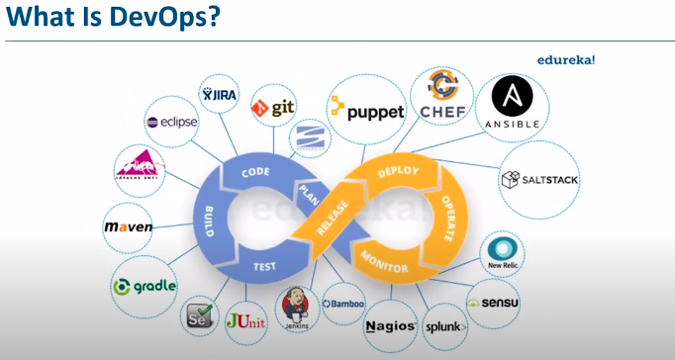

### **What is AWS CodePipeline?**

AWS CodePipeline is a **continuous delivery service** that automates the various steps required to release software efficiently and reliably. It provides a structured pipeline for your workflows, ensuring seamless integration, testing, and deployment of code changes.

### **Key Features of AWS CodePipeline:**

1. **Automation of Workflow Processes**:
2. CodePipeline allows you to automate the build, test, and deployment stages, reducing manual intervention and accelerating delivery.
3. **Real-Time Monitoring**:

Track updates and changes in real-time, ensuring quicker identification and resolution of issues.

1. **Consistent Release Process**:

Automates repetitive tasks like deploying servers, minimizing errors and saving time.

1. **Improved Speed and Quality**:

By automating integration and deployment, CodePipeline enables faster delivery of higher-quality software.

1. **Detailed Pipeline Insights**:

Offers visibility into each stage of your pipeline, including real-time status updates and error detection at specific stages, helping you identify and address issues promptly.

### **How AWS CodePipeline Works**

The CodePipeline workflow consists of several stages:

1. **Source**:

Developers commit changes to a central repository using a service like AWS CodeCommit or Git. Changes are then fetched and prepared for the next stage.

1. **Build**:

Source code is compiled and tested. AWS CodeBuild ensures that artifacts (output files) are generated and stored, often in S3 buckets for accessibility.

1. **Staging**:

The application is deployed to a test environment where final checks are conducted to ensure readiness for production.

1. **Approval**:

Manual or automated approval is performed to verify that everything meets the required standards.

1. **Deployment**:

The tested and approved code is deployed to public servers, making it available to end users.

1. **Feedback Loop**:

Any feedback or changes from the deployment are sent back to the development team, continuing the cycle for iterative improvements.

### **AWS Services Supporting CodePipeline**

1. **AWS CodeCommit**:

Manages your repositories, integrating seamlessly with Git for version control.

1. **AWS CodeBuild**:

Automates the build and test processes, ensuring error-free artifacts are created and stored.

1. **AWS CodeDeploy**:

Automates deployment to production environments, including handling complex scaling and server configurations.

### **Advantages of Using CodePipeline**

* **End-to-End Integration**: Simplifies continuous integration and delivery by connecting different stages seamlessly.
* **Flexibility**: Works with various tools and platforms, including Git and Jenkins.
* **Scalability**: Can handle projects of any size, automatically scaling as needed.
* **Global Accessibility**: Enables geographically distributed teams to collaborate efficiently.